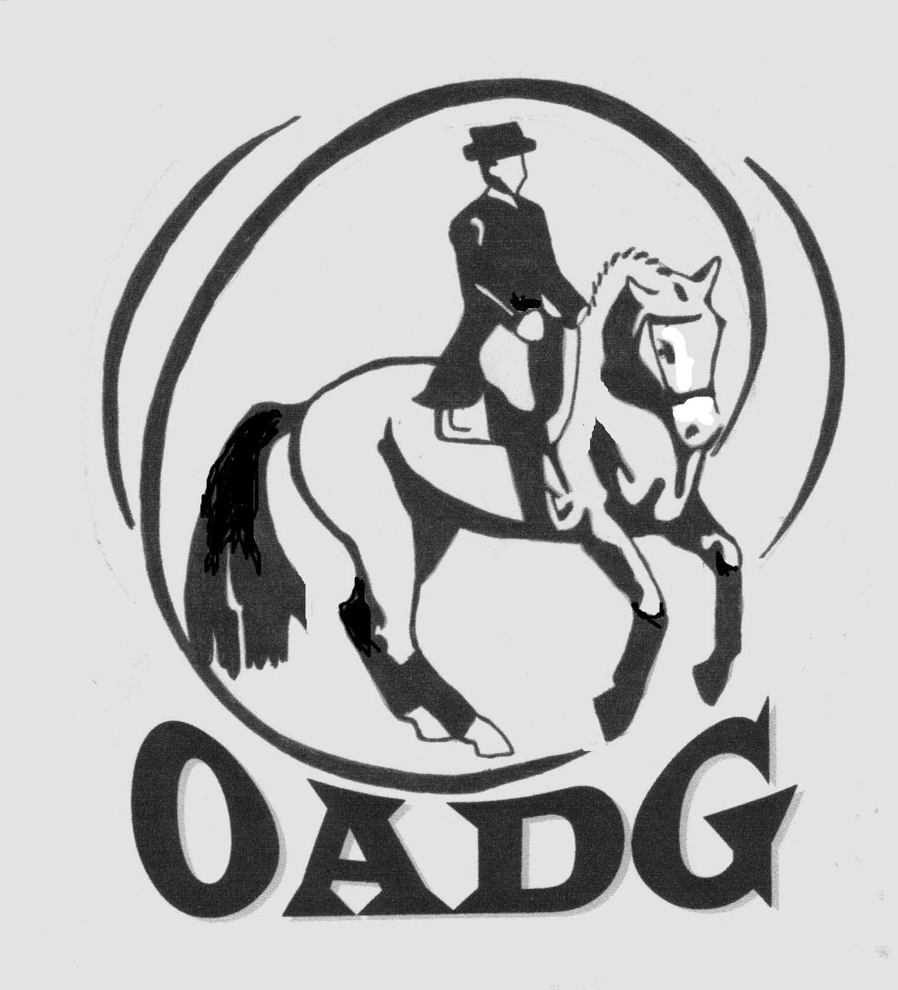
OTTAWA AREA DRESSAGE GROUP
2017 MEMBERSHIP APPLICATION

OADG is a local group affiliated with both CADORA and Dressage Canada.
The OADG is a not-for-profit organization whose purpose is to foster the sport of Dressage by encouraging participation in Competitions, Demonstrations, Lectures and other activities which increase knowledge and understanding of good horsemanship.
Memberships run from January 1st to December 31st and must be renewed with the OADG, CADORA Ontario and CADORA National no later than May 31st to retain voting privileges and ensure eligibility for all applicable awards.

BOTH THE RIDER AND OWNER* OF THE HORSE MUST join no later than May 31st in order to qualify for awards*.
*If different from rider. Owners must have at least an OADG local membership for horse to qualify for OADG awards.
*Scores up to and including May 31st are also valid for year-end awards as long as rider/owner memberships are received by May 31st.

MEMBERSHIP INFORMATION: NEW_______________ RENEWAL_____________ OEF#_____________________
LAST NAME_____________________________________________ FIRST NAME_______________________________________________
ADDRESS_________________________________________________________________________________________________________
CITY_________________________________ PROVINCE__________________________ POSTAL CODE_____________________
HOME PHONE__________________________ CELL PHONE________________________
EMAIL (Please print clearly): _________________________________________________________________________________________
Newsletter Delivery by Email only (or write ‘no newsletter’ following your email address if you do not wish to receive one)
HORSE OWNER NAME(S): ___________________________________________________________________________________________
(SHOW) NAME(S) OF HORSE(S): ______________________________________________________________________________________
DATE OF BIRTH FOR JUNIOR: _______________ JR PARENT/GUARDIAN NAME: ____________________________________
DRESSAGE OFFICIAL: COACH____ JUDGE____ STEWARD____ LEVEL___________________
COMPETITION CATEGORY: JUNIOR____ ADULT AMATEUR____ OPEN____ NON COMPETITOR____
COMPETITION LEVEL: SCHOOLING____ BRONZE____ SILVER____ GOLD____ PLATINUM/CDI____ NON COMPETITOR____
Membership Fees:
(Only a full CADORA National membership includes one Omnibus, CADORA National Membership Card, and CADORA INC newsletters)

MEMBERSHIP TYPES – PLEASE CHOOSE ONE ONLY

OADG LOCAL ONLY SR $30.00_____ JR $20.00_____
CADORA ONTARIO SR $40.00_____ JR $30.00_____ (Includes local membership)
CADORA NATIONAL SR $70.00_____ JR $50.00_____ (Includes local, and Ontario membership)
CADORA QUEBEC NATIONAL SR $60.00_____ JR $40.00_____ (Only for Quebec residents not showing Silver)

Membership Type Selected:______________________ FEE: $___________________________

Supplies: You can only order from these supplies if you have joined CADORA NATIONAL
Additional Omnibus ($20.00 each) $______ Stall Info Card ($5.00 each) $________
Omnibus Rain Cover ($3.00 each) $______ Test Planner ($5.00 each) $________
CADORA Lapel Pin ($5.00 each) $______ CADORA Key Chain ($2.00 each) $________

TOTAL REMITTED FOR MEMBERSHIPS, SUPPLIES (Supplies ONLY for CADORA National members) TOTAL $_____________

Make cheque payable to: Ottawa Area Dressage Group (or OADG) (NO POST DATED CHEQUES PLEASE)

Membership is valid as of the date the completed form and fee are received together by the OADG membership director.
Mail to: Mandy Spear Phone: 613-513-3657
351 Hillsboro Private Email: membership@ottawadressage.ca
Kanata, ON OADG Website: http://ottawadressage.ca/renew/
K2M 3B1
Membership forms may be emailed to membership@ottawadressage.ca IF accompanied by an email money transfer* to the same email.
*Please state your full name(s) in the description box of the transfer for the purpose of clarity.

A membership in any level of the OADG, CADORA Ontario or CADORA National is not required for a rider or horse to compete in dressage competitions, but is required to be eligible for any year-end awards or competition grants sponsored by the OADG, CADORA Ontario or CADORA National.
OTTAWA AREA DRESSAGE GROUP
2017 MEMBERSHIP INFORMATION

Privacy Policy: The OADG will not share your personal information with third parties unless required for business directly related to the OADG (such as forwarding member information to CADORA). If we judge an issue or information item to be of interest to our members, we will forward that information to you directly by email from within the OADG Director group.

The OADG membership packages are divided by levels identifying total fees required to join either: OADG (local group), CADORA Ontario (COAI), or CADORA National. There is also a level for those residing in Quebec, not having a provincial affiliate and thus not required to join CADORA Ontario. Each member can choose the membership package that fits their particular preferences.

A membership in any level of OADG, CADORA Ontario or CADORA National is not required for a rider or horse to compete in dressage competitions. However; it is necessary for both the rider and at least one owner of the horse (if different) to be members in order to be eligible for any year-end awards or competition grants sponsored by the OADG, CADORA Ontario or CADORA National. Memberships are required to be in by May 31st to be eligible for OADG, CADORA Ontario or CADORA National awards.

MEMBERSHIP PACKAGES:

LOCAL: OADG Local membership ONLY (Senior/Junior)
ONTARIO: OADG Local membership and CADORA ONTARIO membership (Senior/Junior)
NATIONAL: OADG Local membership and CADORA Ontario membership and CADORA National membership (Senior/Junior)
QUEBEC NATIONAL: OADG Local membership and CADORA National membership (Senior/Junior)

The following is a summary of what each membership package includes:

LOCAL – OADG  Ottawa Area Dressage Group | - Eligible for local OADG year-end awards for FEI, Gold, Silver, Bronze, Schooling Permit competitions. Rider and at least one owner of the horse must be members by May 31st to be eligible for year-end awards.  - Local OADG shows are designated in the Local column at http://ottawadressage.ca/shows/  - See http://ottawadressage.ca/awards/ for awards criteria, which include external show scores  - OADG Local group newsletter  - Eligible to ride in OADG sponsored clinics  - Eligible to vote in local OADG group elections at AGM, and stand for director  - Affiliated with Dressage Canada
ONTARIO - COAI  Cadora Ontario Association Inc. | Local OADG Package plus:  - Eligible for COAI, Silver, Bronze awards  - CADORA Ontario newsletters  - Vote in COAI elections and stand for director  - Access to CADORA Ontario scholarship programs
NATIONAL -  Cadora National Inc. | Ontario package plus:  - One CADORA Omnibus  - CADORA National quarterly newsletters  - Purchase CADORA National supplies (Omnibus, lapel pin, rain covers)  - Eligible for CADORA National FEI, Gold awards  - Vote in CADORA National elections at AGM and stand for Director (if renewed by May 31st)

Quebec residents competing on the Ontario Silver circuit must join CADORA Ontario to be eligible for year-end CADORA Ontario Silver awards. Quebec residents do have the option of not joining CADORA Ontario if they are not competing on the Ontario Silver Circuit.

Supplies: Supplies are for CADORA NATIONAL members ONLY

Note: All OADG members participating in OADG shows and clinics must be members of the OEF for insurance purposes. It is recommended that clinic organizers ask for participant OEF number.

Please do not send the OADG membership director Ontario Equestrian Federation (OEF) memberships or Equine Canada (EC) memberships or Dressage Canada (DC) memberships. These should be sent directly to the respective OEF or EC membership offices.

