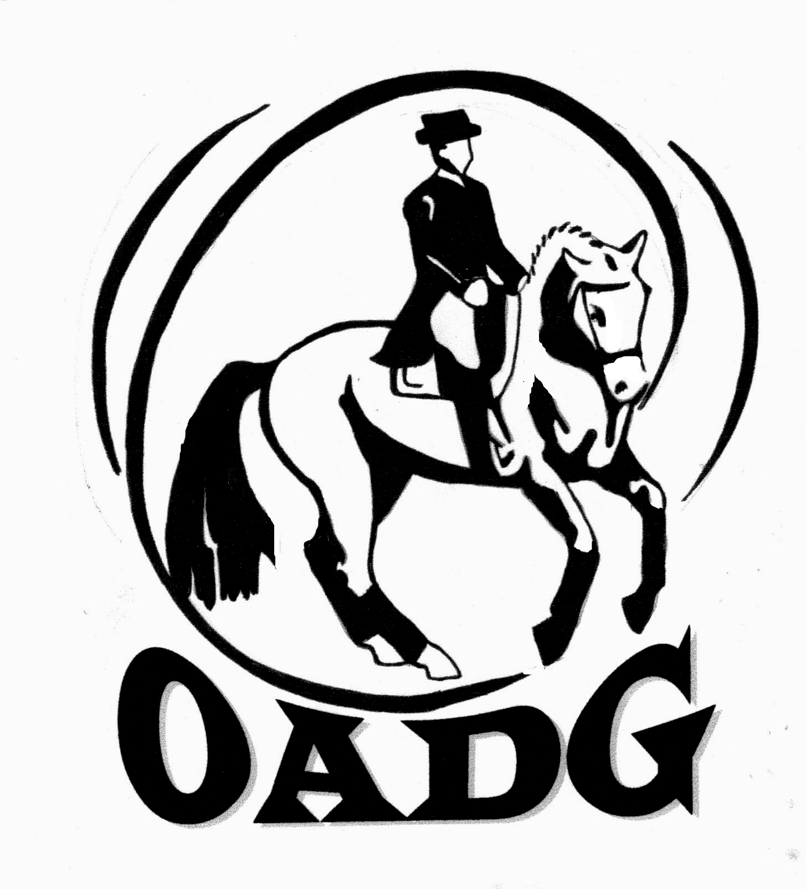
2011 OADG Horse Owner of the Year Submission Form

Please submit by October 10th, 2011

Do you wish to recognize the owner of the horse that you are competing on? The purpose of this award is to nominate a unique and supportive horse owner - who through their ownership of the horse, have demonstrated a commitment to the sport of Dressage and furthering another’s equestrian skills, without any benefit to themselves. In 2009, Zachary Ball presented the inaugural trophy to Sarah McIlwham, the owner of the horse he rode. Riders may nominate an OADG member who is a horse owner and provides a horse for competition.
Criteria:
- Both riders and owners must be OADG members.
- A small essay must be written by the rider defining why the owner deserves such an award.
- The owner must have assisted the rider with obtaining their personal goals for this year.

Name of Owner: _____________________________________________

Name of Rider: ______________________________________________

Name of Horse:______________________________________________

Essay: (please use another page if you need more room)

Rider’s Signature: ____________________________ E-mail: _______________________________________

Contact Phone Number: ________________

Mail to: Or email to: awards@ottawadressage.ca
Basia Anders (signature not required)
308 Lowe Road
Ashton, Ontario K0A 1B0
613-257-1914

