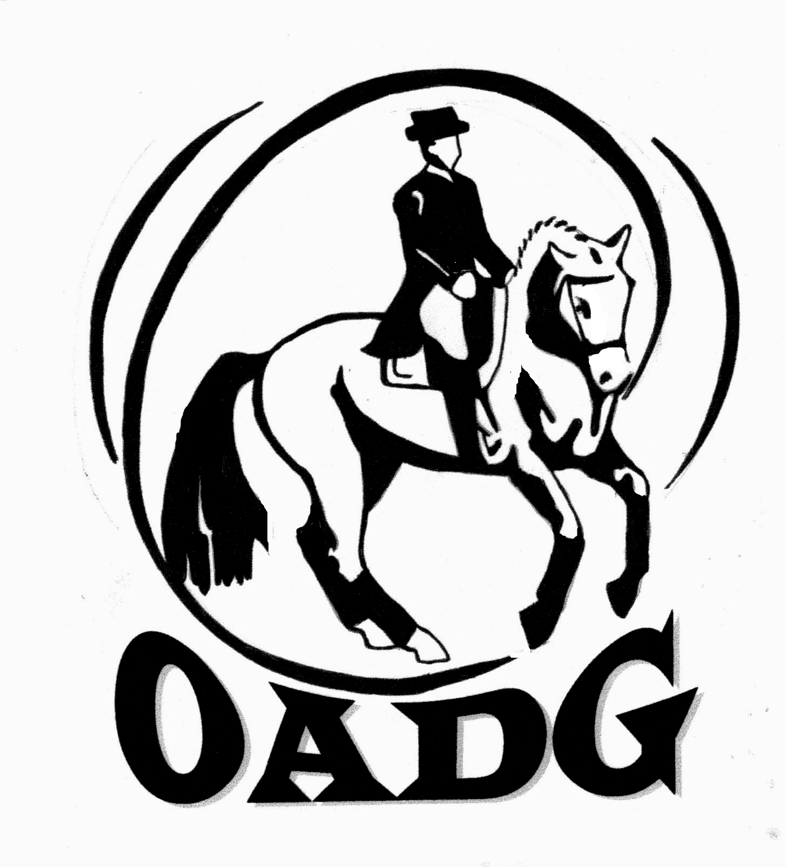
2011 OADG Senior Rider Award Submission Form

Please submit by October 10th, 2011

CRITERIA:

- This is an optional award, open to all AA and Open riders who are 55 years of age or over.
- You must be an OADG member.
- Scores can only be submitted from Ottawa area shows (OEF Schooling, Silver, or Gold Circuits) - those marked as "N" in the External column of the show calendar.
- Scores must be for the same horse, showing at the same level, and on the same circuit.
- Submit three scores from a minimum two Ottawa shows.

Name of Rider: _________________________________________

Name of Horse: _________________________________________

Results: Please list the top 3 scores to 3 decimal places according to the criteria above. If your ride was judged by more than one judge, please submit only the combined score. If any scores are from Gold shows, please verify that they are on the EC website. If not, attach copies of the test papers for those scores, or include website where scores can be verified.

Show Location | Date | Class/Level | Judge(s) | Score | Website

Sum of top three scores: _____________ Date of Birth: _______________________________

Rider’s Signature: ____________________________ E-mail: _______________________________________

Contact Phone Number: ________________

Mail to: Or e-mail to: awards@ottawadressage.ca
Basia Anders (signature not required)
308 Lowe Road
Ashton, Ontario K0A 1B0
613-257-1914

