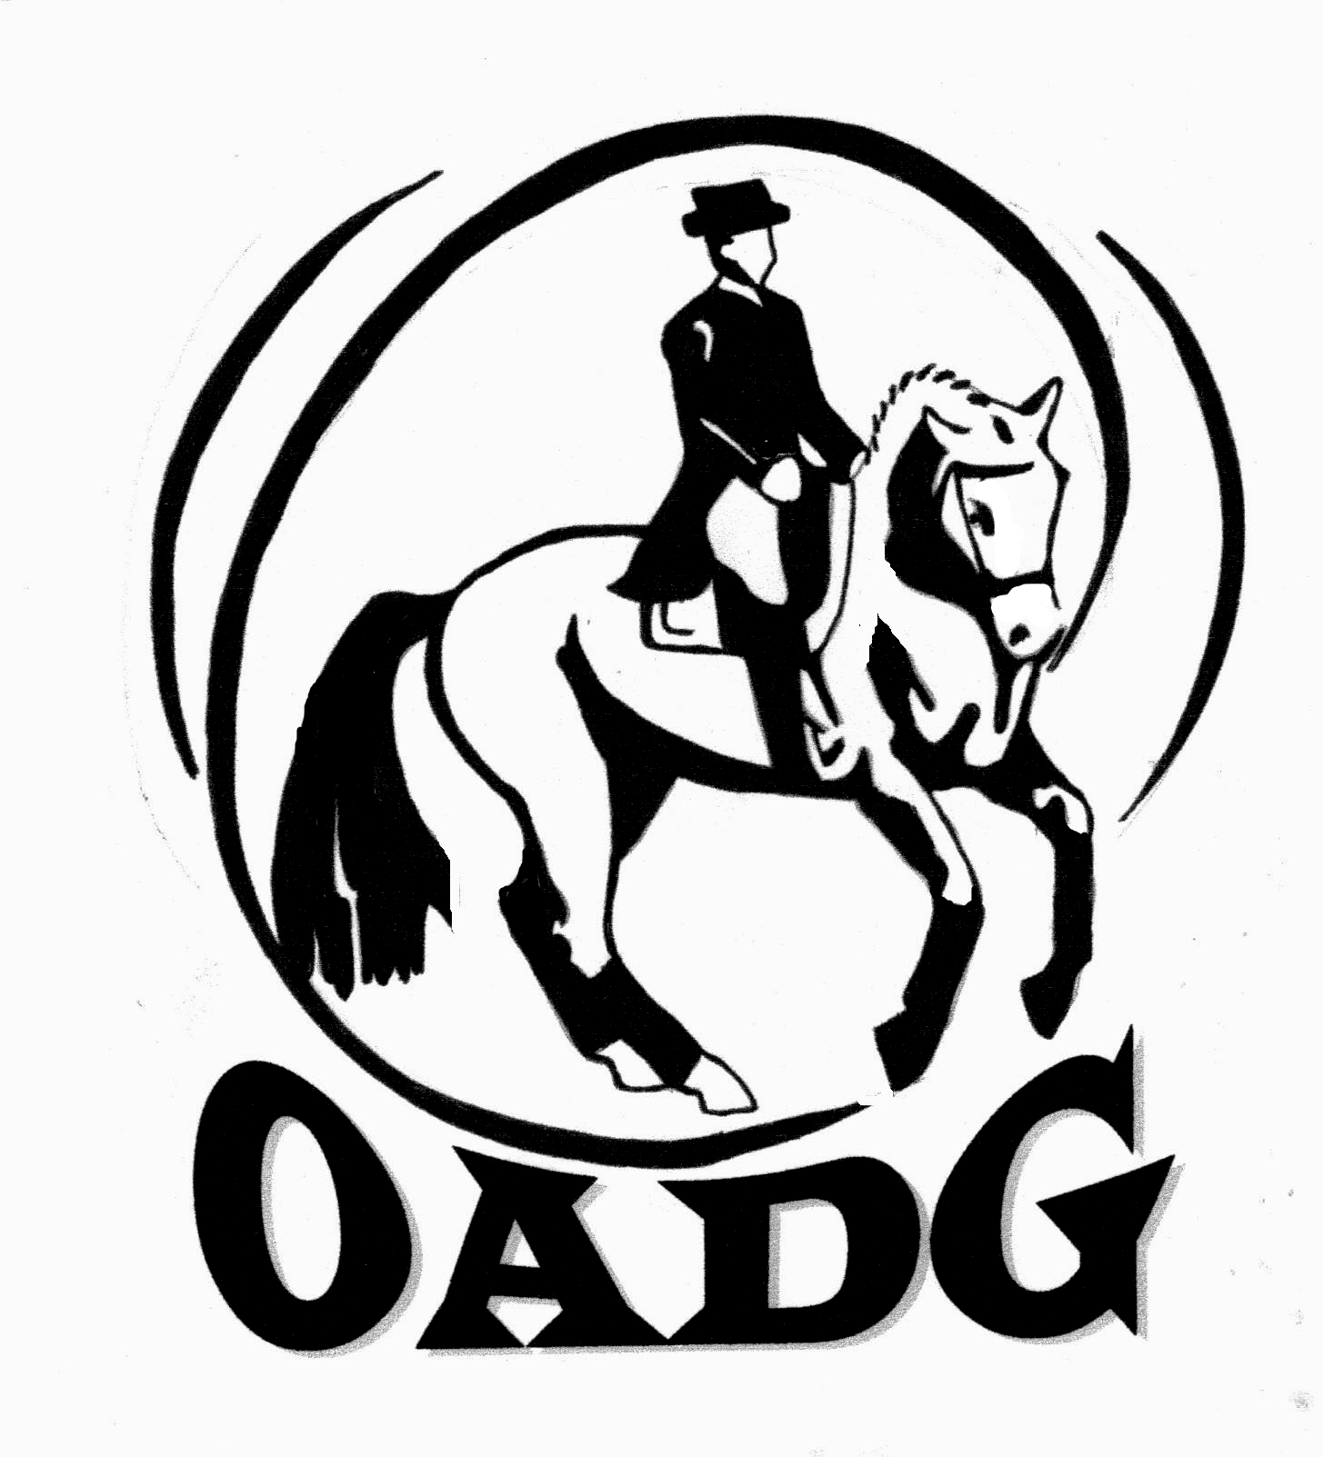
2012 OADG Year End Awards Submission Form
Please submit by October 10th, 2012

This form is not required if you are showing on the OEF Schooling circuit since the OADG tracks all the local OEF Schooling shows, and no external show scores are eligible for OEF Schooling Awards.
This form is not required if you are showing on the Gold or Silver Circuits and have no external show scores since the OADG tracks all the local Gold and Silver shows.
This form is required if you are showing on the Gold or Silver Circuits and have an external show score.
This form is required if you are showing on the FEI circuits.
This form is required if you are a Peewee (10 and under) and you are not an OADG member.
If you are submitting scores for the Young Horse Award, please use the form entitled “Young Horse Award Form”.

Circuit (underline one): OEF Schooling Silver Gold FEI

Division (underline one): PeeWee Junior AA Open

Level:__________________________________ (Walk/Trot, Training, First, Second.....)

Name of Rider: ______________________________________________ Age if Pee Wee:____ (10 or younger)

Name of Owner: _____________________________________________
Name of Horse:______________________________________________

Criteria – Please see full criteria details on website www.ottawadressage.ca or included in the newsletter

Results: Please list your top four results (to 3 decimal places). Please refer to the Awards Criteria to determine the minimum number of shows and maximum number of scores allowed per show for your level/division/circuit.
If your ride was judged by more than one judge, please submit only the combined score.
If any scores are from Gold, Silver or FEI shows outside the Ottawa area, please verify that they are on the EC website. If not, attach copies of the test papers for those scores, or include website where scores can be verified.

Show Location | Date | Class | Judge(s) | Score | Website

Sum of top three scores: ________ Sum of top four scores (for Horse World Medals): ______________

Rider’s Signature: ____________________________ E-mail: _______________________________________

Contact Phone Number: ________________

Mail to: Or email to: awards@ottawadressage.ca
Pierre Paquette (signature not required)
1545, 9h Line Road, R.R. 1,
Metcalfe, Ontario K0A 2P0

