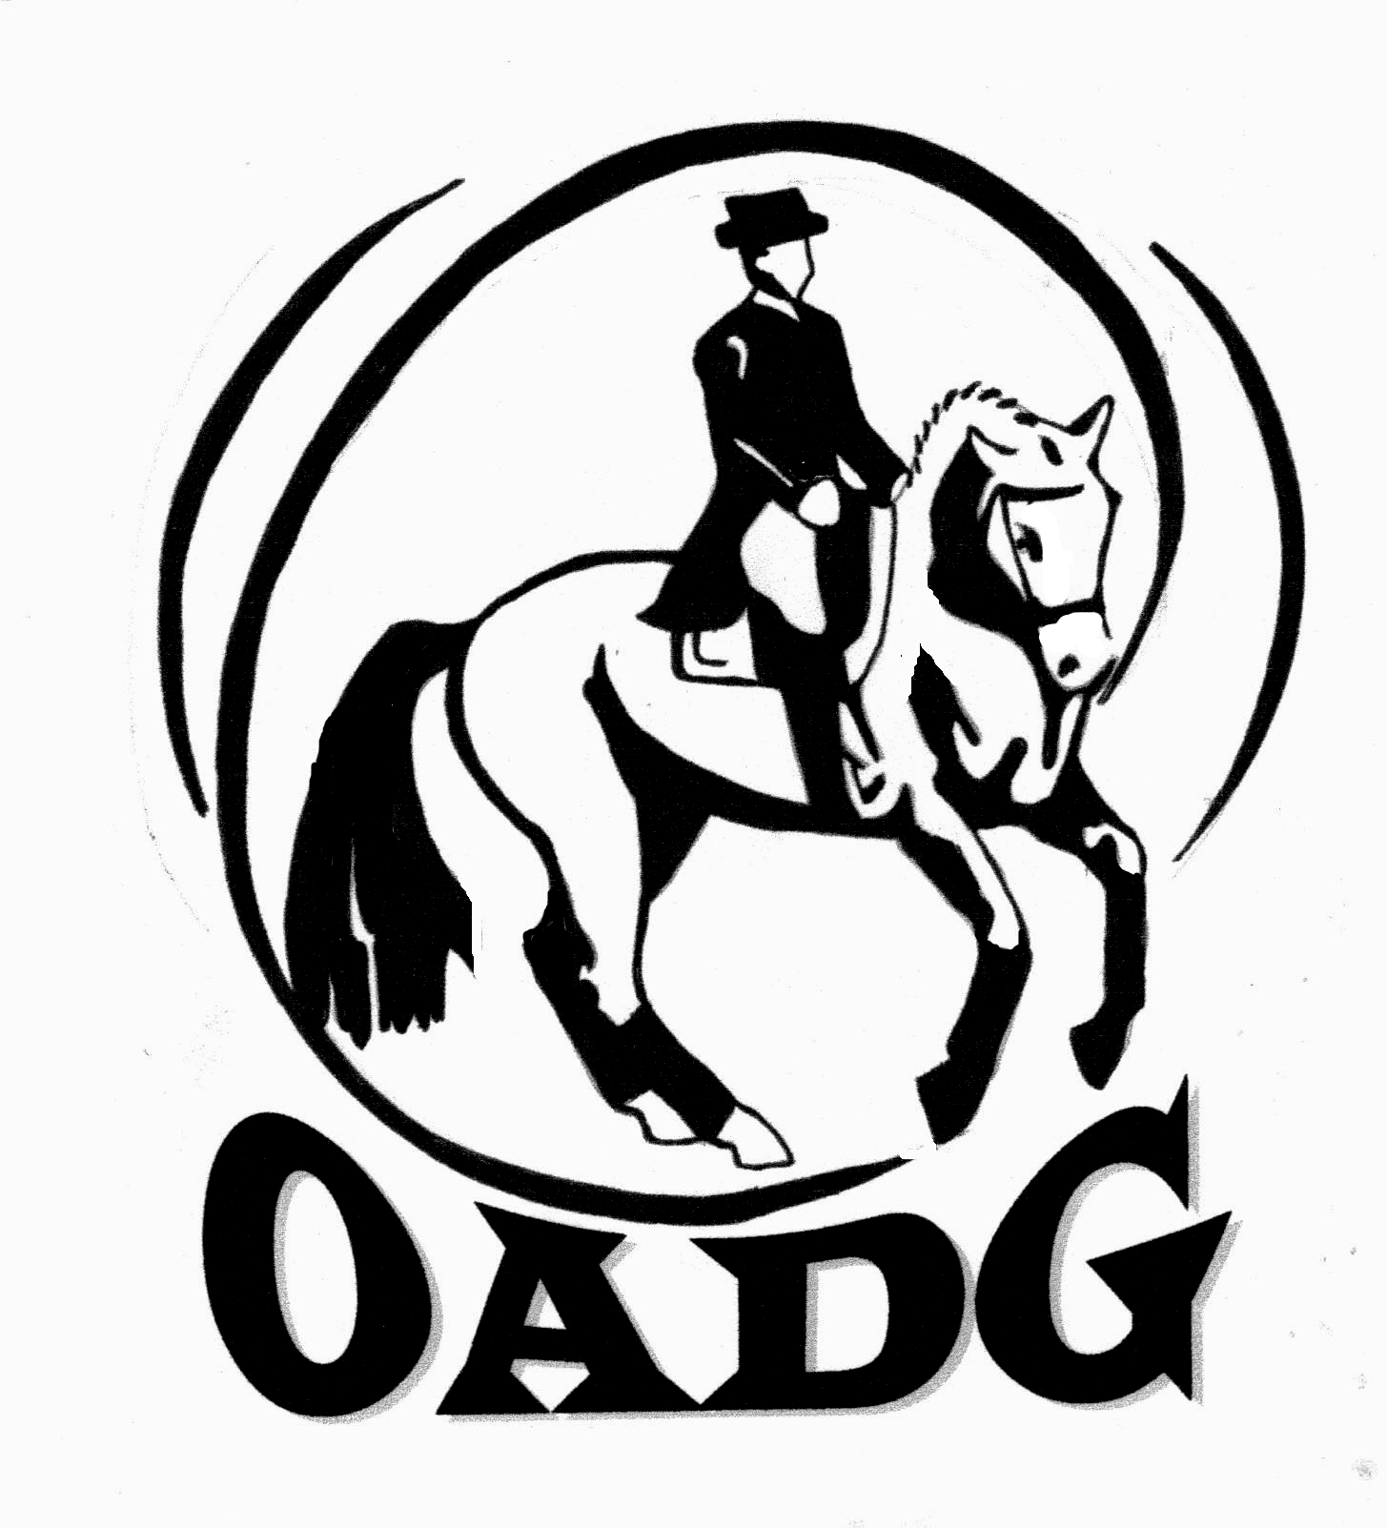
2012 OADG Young Horse Award Submission Form

Please submit by October 10th, 2012

CRITERIA:

- There is one Young Horse Award for each of the three circuits (OEF Schooling, Silver, Gold).
- Horses must be 6 years old or younger.
- Riders can be Peewee, Junior, AA, or Open but must be OADG members.
- At least one owner must be a OADG member.
- Scores can be from any level or multiple levels, but not W/T or freestyle tests.
- Use of scores from external shows are as follows:
  - OEF Schooling: none allowed
  - Silver: one external Canadian show allowed
  - Gold: two external Canadian shows allowed.
- Number of shows and scores per show:
  - OEF Schooling: three scores from three separate shows
  - Silver/Gold: three scores from at least 2 shows (no more than 2 scores per show).

Criteria – Can also be found on the website www.ottawadressage.ca

Circuit (underline one): OEF Schooling Silver Gold

Name of Horse: _________________________________________ Age of Horse :________ (must be 6 or under)

Name of Owner: ________________________________________
Name of Rider: _________________________________________

Results: Please list the top 3 scores (over 50%) to 3 decimal places according to the criteria above related to the number of shows and number of scores per show. If your ride was judged by more than one judge, please submit only the combined score. If any scores are from Gold shows, or Silver shows outside of Ottawa, please verify that they are on the EC website. If not, attach copies of the test papers for those scores, or include website where scores can be verified.

Show Location | Date | Class/Level | Judge(s) | Score | Website

Sum of top three scores: _____________

Rider’s Signature: ____________________________ E-mail: _______________________________________

Contact Phone Number: ________________

Mail to: Or e-mail to: awards@ottawadressage.ca
Pierre Paquette (signature not required)
1545, 9th Line Road, R.R. 1,
Metcalfe, Ontario K0A 2P0

