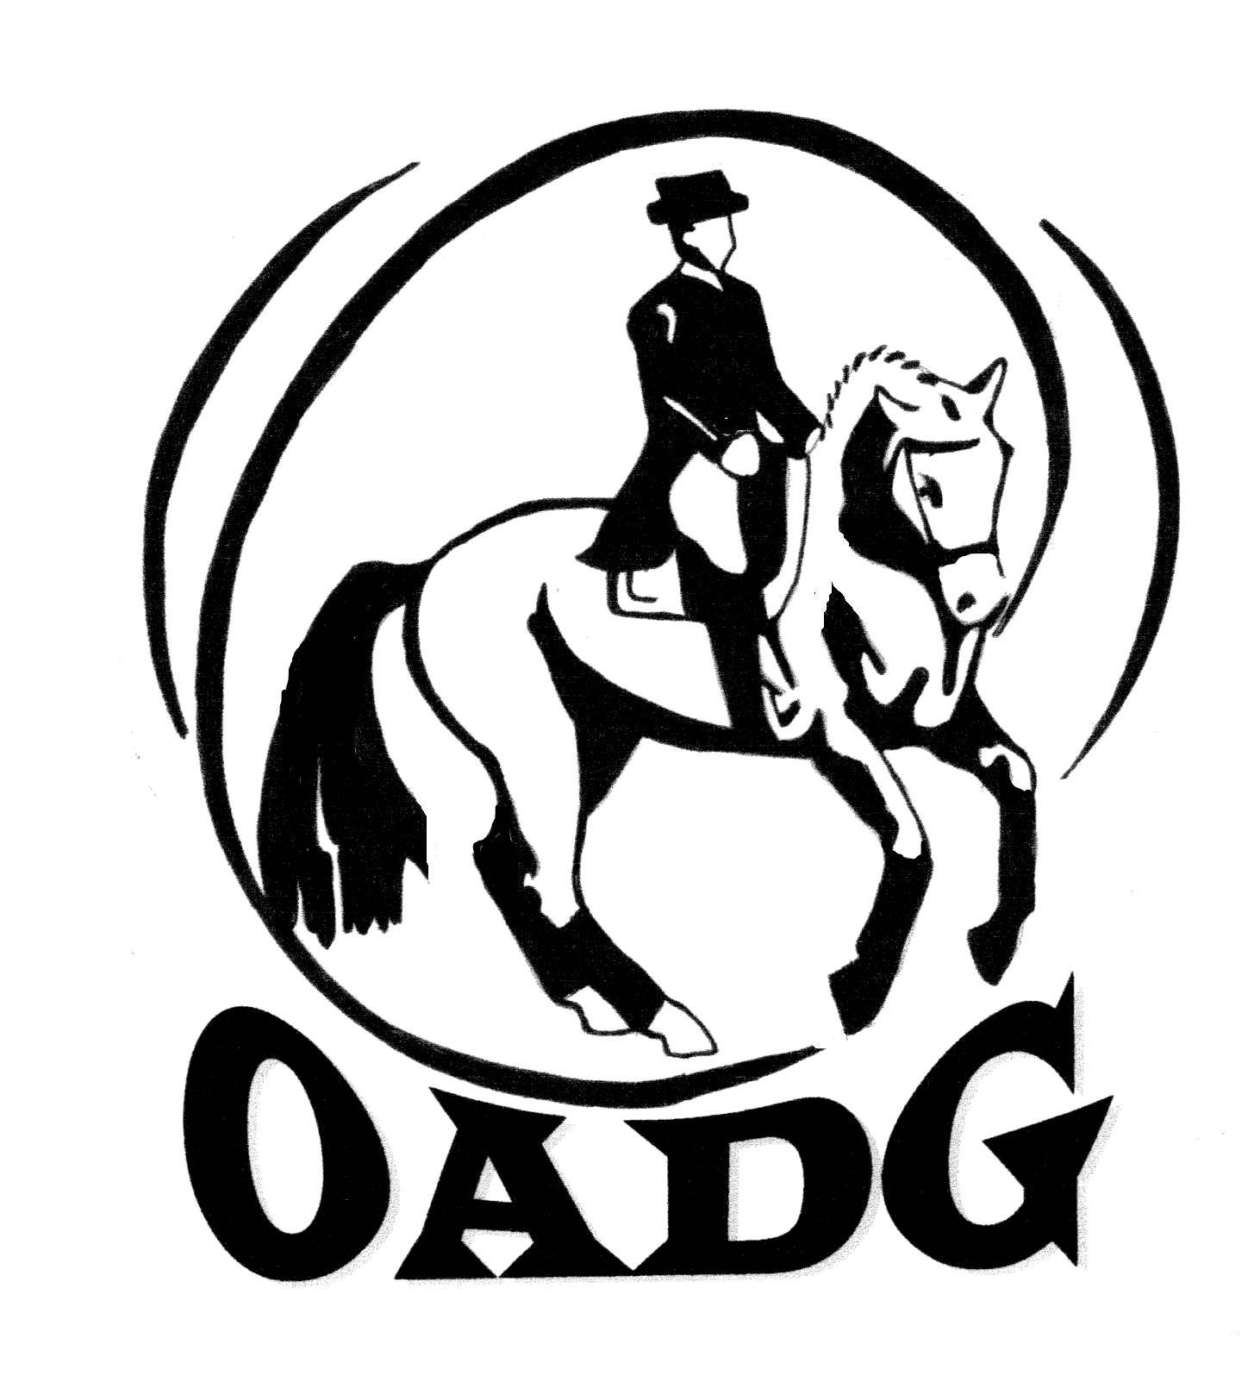

2013 OADG Young Horse Award Submission Form

Must be submitted by October 7, 2013

There is one Young Horse Award for each of the three circuits (OADG Schooling, Silver, or Gold). If you are applying for more than one circuit, separate forms must be provided.

Criteria can be found on the website www.ottawadressage.ca

Circuit (underline one): OADG Schooling Silver Gold

Name of Horse: _________________________________________ Age of Horse :________ (must be 6 or under)

Name of Owner: ________________________________________
Name of Rider: _________________________________________

Results: Please list eligible scores to 3 decimal places. If your ride was judged by more than one judge, please submit only the combined score. If any scores are from external Gold or Silver shows please attach copies of the test papers for those scores, or include website where scores can be verified.

Show Location | Date | Class/Level | Judge(s) | Score | Website

Sum of top three scores: _____________

Rider’s Signature: ____________________________ E-mail: _______________________________________

Contact Phone Number: ________________

Mail to: or e-mail to: awards@ottawadressage.ca
(signature not required)
Catherine Maguire, OADG Awards Director
1200 Clayton Road, RR 1
Almonte, ON
K0A 1A0
must be received by the deadline

