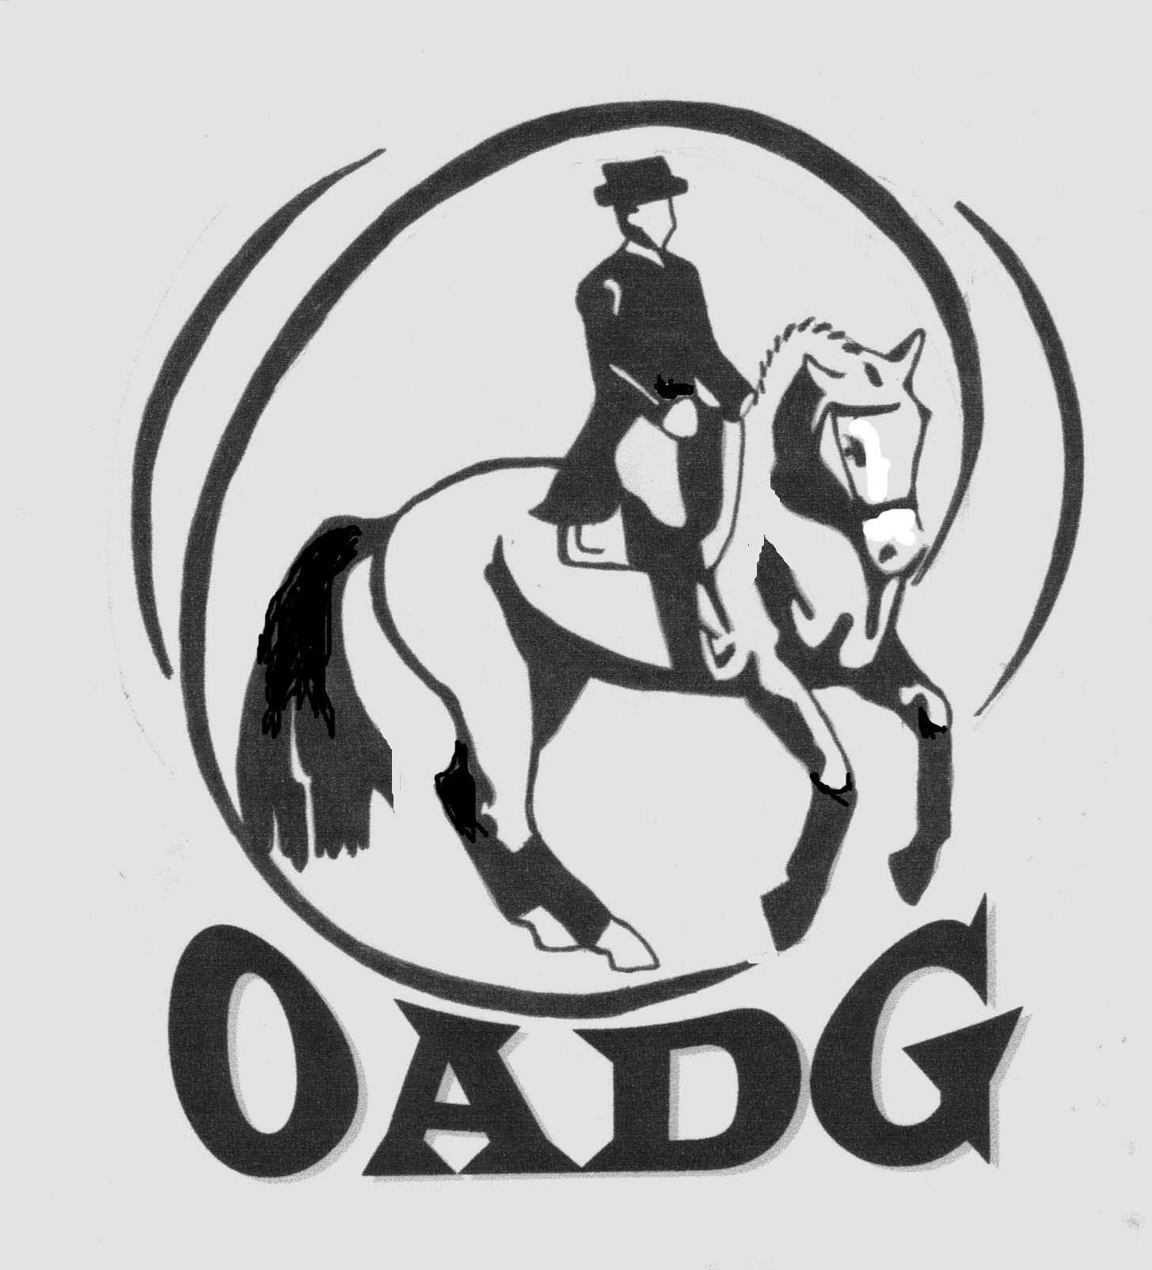

2014 OADG Awards Criteria
Please take note of the following general criteria, plus be aware of any additional criteria specific to your show circuit in the sections that follow.

- To be eligible for a year-end award, both the Owner and Rider of the Horse must be OADG members by May 31, 2014. Membership by May 31 is deemed to be for the calendar year -- shows attended prior to joining will be retroactively reflected in a member’s official results.
- As part of its activities, the OADG sponsors prizes at local area shows in the following competition circuits: OEF-Schooling, Silver, Gold or Platinum (note: Platinum or FEI/CDI shows are not always offered each season – check the show listings). The list of the “local” shows is posted on the OADG website.
- External shows are defined as those not sponsored by the OADG – the more popular regional shows in Ontario/Quebec are listed on the OADG website. Both “local” and “external” show scores are permitted for year-end award eligibility as set out in this detailed criteria -- see the specific competition circuit in the following tables. Please note the exception for OEF-Schooling awards where no external scores are permitted.
- ONLY local show results will be tracked by the awards committee. Where an external score is permitted, an “External Scores Submission Form” is required to be submitted by the competitor.
- Interim results will be published on the OADG website. It is the competitors’ responsibility to verify their own results and notify the Awards Director as soon as possible of any errors or omissions.
- The team concept (horse and rider) applies for results tracking. If a horse or rider has a name change during the course of the season, the Awards Director must be notified.
- A unique Category (JR, AA, or O) also applies for results tracking. No combining of results will be permitted for horse-rider teams who switch from AA to O, for example, in mid-season. Additionally, a horse-rider team must actually ride in a class for the score to count for OADG awards. Add-on scores will be dropped from the tracking sheet.
- New for 2014 is the Team Challenge Award. Teams of 3 members may enter only one Challenge: Schooling, Silver or Gold. A team member is defined as a discrete horse/rider combination. Riders can be a mix of JR, AA or O. A team member can participate on only one team; however a specific horse OR rider is eligible to participate on another team. The deadline for declaring your team is either a) end of May for those competing before the membership deadline or b) before the first show of the season for those competing from June onwards.
- Scores from one circuit (i.e. Gold) cannot be counted towards another circuit (i.e. Silver).
- If more than one judge judges the same ride, the average of the scores of the judges will be counted as the official score.
- Only Equine Canada approved tests are eligible for OADG Awards. The only exceptions are the CADORA Walk/Trot tests used for W/T Rider and W/T Horse classes, and the Training Level Freestyle test as there is no Equine Canada freestyle available at this level.
- The same horse-rider team may be awarded OADG year-end Champion or Reserve Champion in the Silver and Gold circuits at the same level. This does not apply should the competitor qualify in the OEF Schooling circuit as well as Silver and/or Gold at the same level. In this case only win the higher circuit trophy is awarded.
- Any required year end Award forms must be received by the OADG Awards Director by October 6, 2014. Forms are available on the Awards page of the OADG website.
- Additional specific criteria for each circuit are outlined in the tables below.
OADG Schooling Series Awards

- To be eligible, a horse-rider team must have 3 scores >50%, from 3 different shows and a minimum 2 different sites.
- All shows must be local OEF-Schooling (also known as OEF Equestrian Skills Development – ESD) shows. Eligible shows are indicated as “local” on the show section of the website.
- Scores from ‘Special Request’ or “Test of Choice” classes will not be counted towards Year End Awards.
- PeeWee, Young Horse and Team Challenge award forms are required for those specific awards. Note: Team Challenge declaration forms are due May 31, 2014.

Award | Level | Category
OADG | W/T Horse | JR, AA and O
 | W/T Rider | JR and AA
 | Equitation WT | All categories combined
 | Equitation WTC | All categories combined
 | Training | JR, AA and O
 | First | JR, AA and O
 | Musical Combination | All categories combined
PeeWee | All levels combined | PeeWee (12 yrs. & under)
Young Horse  (Horses 6 yrs. & under) | All levels combined  (excludes W/T &  Freestyle) | All categories combined
Team Challenge | All levels combined | JR/AA combined
Merit  3 scores ≥ 60%  From 3 different shows  Minimum 2 different sites | W/T Horse | JR and AA
 | W/T Rider | JR and AA
 | Training | JR and AA
 | First | JR and AA

Definitions of PeeWee for the Awards
- A competitor is a PeeWee until the end of the calendar year in which they reach the age of 12.

OADG Silver Series Awards
- To be eligible, a horse-rider team must have 3 scores >50%, from 3 different shows and a minimum 2 different sites.
- At least 2 of the shows must be local OADG sponsored EC Silver Shows.
- One score may be a non-local (or external) EC Silver Show elsewhere in Canada.
- Scores from the Eastern Silver Championships may be used and will be tracked by the OADG. Scores from the Western Silver Championships may be used, but must be reported as external scores.
- FEI Freestyles will be used for the Silver Freestyle Awards at the equivalent EC level.
- CADORA Freestyles will be used for the Training Level.
- Young Horse, Team Challenge and External Scores Submission Forms are required where applicable. Note: Team Challenge declaration forms are due by May 31, 2014.

Award | Level | Category
OADG | Training | JR, AA and O
 | First | JR, AA and O
 | Second | JR, AA and O
 | Third | JR, AA and O
 | Fourth | JR, AA and O
 | FEI Children, JR, Pony  & YR | All categories combined
 | FEI Advanced  (PSG, I1, I2) | AA and O combined
 | Training Freestyle | All categories combined
 | First Freestyle  (incl. FEI Children  Freestyle) | All categories combined
 | Second Freestyle  (incl. FEI Pony Freestyle) | All categories combined
 | Third Freestyle  (incl. FEI JR Freestyle) | All categories combined
 | Fourth Freestyle  (incl. FEI YR Freestyle) | All categories combined
Young Horse  (Horses 6 yrs. & under) | All levels combined  (excludes Freestyle) | All categories combined
Team Challenge | All levels combined | All categories combined
Merit  3 scores ≥ 65%  From 3 different shows  Minimum 2 different sites | Training | JR, AA and O
 | First | JR, AA and O
 | Second | JR, AA and O
 | Third | JR, AA and O

OADG Gold Series Awards

- To be eligible, a horse-rider team must have 3 scores >50%, from 3 different shows and a minimum 2 different sites.
- At least one of the shows must be an OADG sponsored local EC Gold Show.
- Two scores may be from non-local (or external) Gold Shows elsewhere in Canada or USA.
- Young Horse, Team Challenge and External Scores Submission Forms are required where applicable. Note: Team Challenge Declaration Forms are due May 31, 2014.

Award | Level | Category
OADG | Training | JR, AA & O
 | First | JR, AA & O
 | Second | JR, AA & O
 | Third | JR, AA & O
 | Fourth | JR, AA & O
 | First Level Freestyle | All categories combined
 | Second Level Freestyle | All categories combined
 | Third Level Freestyle | All categories combined
 | Fourth Level Freestyle | All categories combined
Young Horse  (Horses 6 yrs. & under) | All levels combined  (excludes Freestyle) | All categories combined
Team Challenge | All levels combined | All categories combined
Merit  3 scores ≥ 65%  From 3 different shows  Minimum 2 different sites | Training | JR, AA and O
 | First | JR, AA and O
 | Second | JR, AA and O
 | Third | JR, AA and O
 | Fourth | JR, AA and O

OADG FEI Awards for FEI classes at Gold or CDI Shows

- To be eligible, a horse-rider team must have 3 scores >50%, from 3 different shows and a minimum 2 different sites.
- At least 1 of the shows must be an OADG sponsored local EC Gold show offering FEI classes, or an FEI CDI Show (in years where one is offered locally).
- Two scores may be a non-local (or external) EC Gold Show or CDI elsewhere in Canada or USA.
- An External Scores Submission Form is required where applicable.

Award | Level | Category
FEI at Gold & CDI shows | Pony (Individual & Team) | All categories combined
 | Pony Freestyle | All categories combined
 | Children (Individual &  Team) | FEI Children
 | Junior (Individual & Team) | JR
 | Junior Freestyle | JR
 | Young Rider (Individual &  Team) | YR
 | Young Rider Freestyle | YR
 | Prix St Georges | AA and O combined
 | Intermediare 1 | AA and O combined
 | Intermediare 2 | AA and O combined
 | Intermediare Freestyle | AA and O combined
 | Grand Prix & Grand  Prix Special | AA and O combined
 | Grand Prix Freestyle | AA and O combined
 | FEI 4 Year Old | AA and O combined
 | FEI 5 Year Old | AA and O combined
 | FEI 6 Year Old | AA and O combined

OADG Special Year-End Awards for OADG Members

Dr. Brian Mills Award
Awarded to the OADG outstanding Junior Rider at the Gold, CDI or FEI level.
Names are put forward by the OADG Board.
Award is determined by the Dr. Brian Mills Memorial Fund and announced at
the Year-End Awards Banquet.

Horse Owner of the Year Award
OADG member riders may nominate an OADG member who is a horse owner and provides a horse for
competition.
Submission of a Horse Owner of the Year Award Form is required.
Decision is by voting of the OADG Board.
Volunteer of the Year Award
OADG members may nominate an OADG member.
Submission of a Volunteer of the Year Award form is required.
Decision is by voting of the OADG Board.
Senior Rider of the Year Award
Sum of top 3 marks by an Open or AA horse-rider team where the rider is ≥ 55 years.
Scores can be from any OADG local show but must be from the same circuit.
The scores must be from at least 2 different sites.
Submission of a Senior Rider of the Year Award form is required.
Para-Equestrian Rider of the Year Award
Sum of top 3 marks >50% by a Para-Equestrian Rider.
Scores can be from 3 different shows, any show circuit and any level, providing two are
from local shows.
The scores must be from at least 2 different sites.
Submission of a Para-Equestrian Rider of the Year Award form is required.
Other possible special awards to be decided by Board.
OADG special award to 2013 Eastern Division Champions & Freestyle champions.
OADG special award to 3 highest scores overall in each show circuit.

