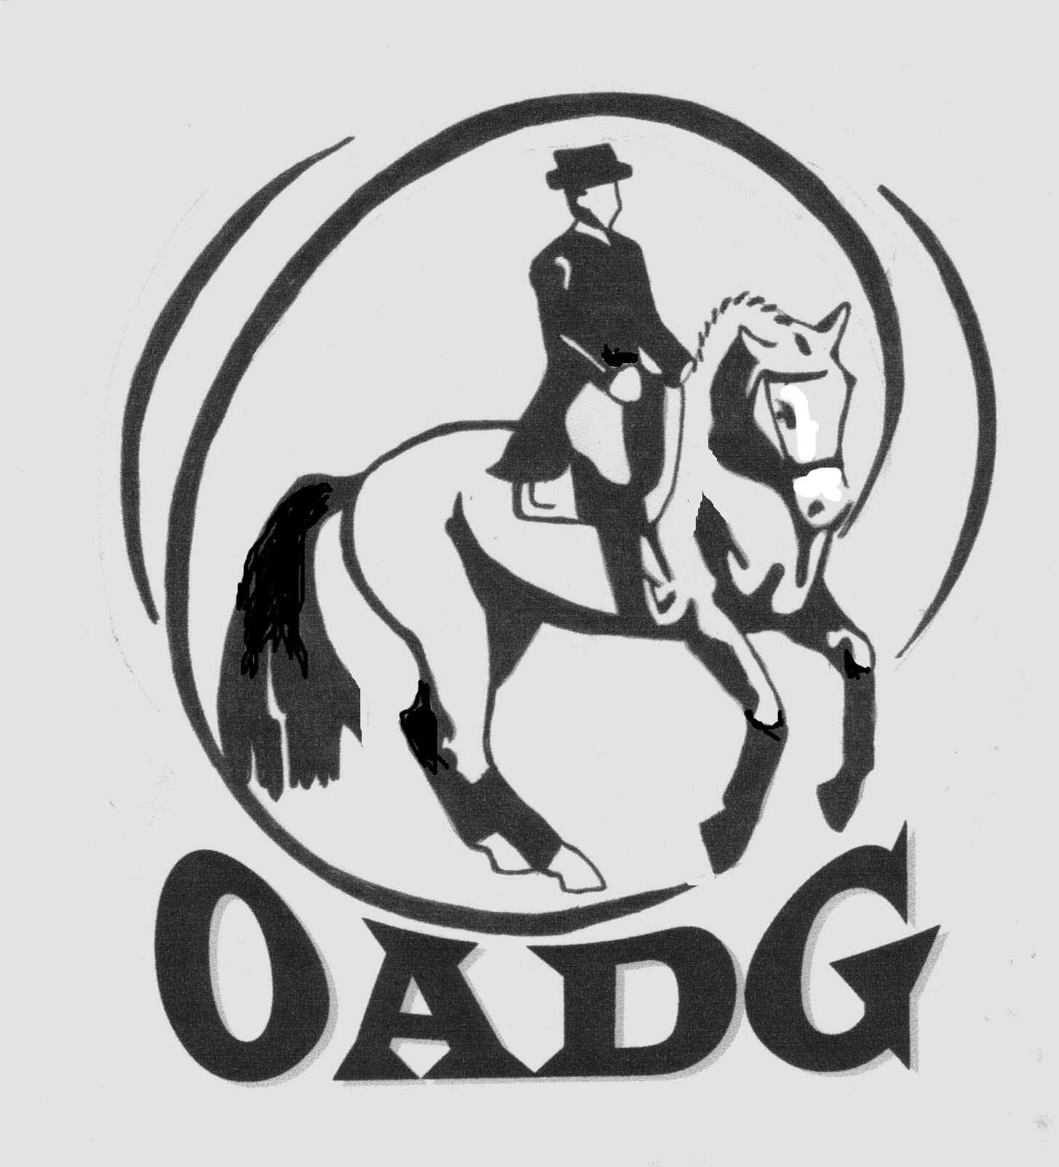

# 2014 OADG Young Horse Award Submission Form

# Must be submitted by October 6, 2014

There is one Young Horse Award for each of the three circuits (OADG Schooling, Silver, or Gold). If you are applying for more than one circuit, separate forms must be provided.

**Criteria can be found on the website** [**www.ottawadressage.ca**](http://www.ottawadressage.ca)

**Circuit (underline one):** OADG Schooling Silver Gold

Name of Horse: _________________________________________ Age of Horse :________ (must be 6 or under)

Name of Owner: ________________________________________

Name of Rider: _________________________________________

**Results**: Please list eligible scores to 3 decimal places. If your ride was judged by more than one judge, please submit only the combined score. **If any scores are from external Gold or Silver shows please attach copies of the test papers for those scores, or include website where scores can be verified.**

|  |  |  |  |  |  |
| --- | --- | --- | --- | --- | --- |
| **Show Location** | **Date** | **Class/Level** | **Judge(s)** | **Score** | **Website** |
|  |  |  |  |  |  |
|  |  |  |  |  |  |
|  |  |  |  |  |  |
|  |  |  |  |  |  |

Sum of top three scores: _____________

Rider’s Signature: ____________________________ E-mail: _______________________________________

Contact Phone Number: ________________

**Mail to: or e-mail to:** [awards@ottawadressage.ca](mailto:awards@ottawadressage.ca)

(signature not required)

Catherine Maguire, OADG Awards Director

1200 Clayton Road, RR 1

Almonte, ON

K0A 1A0

*must be* ***received*** *by the deadline*