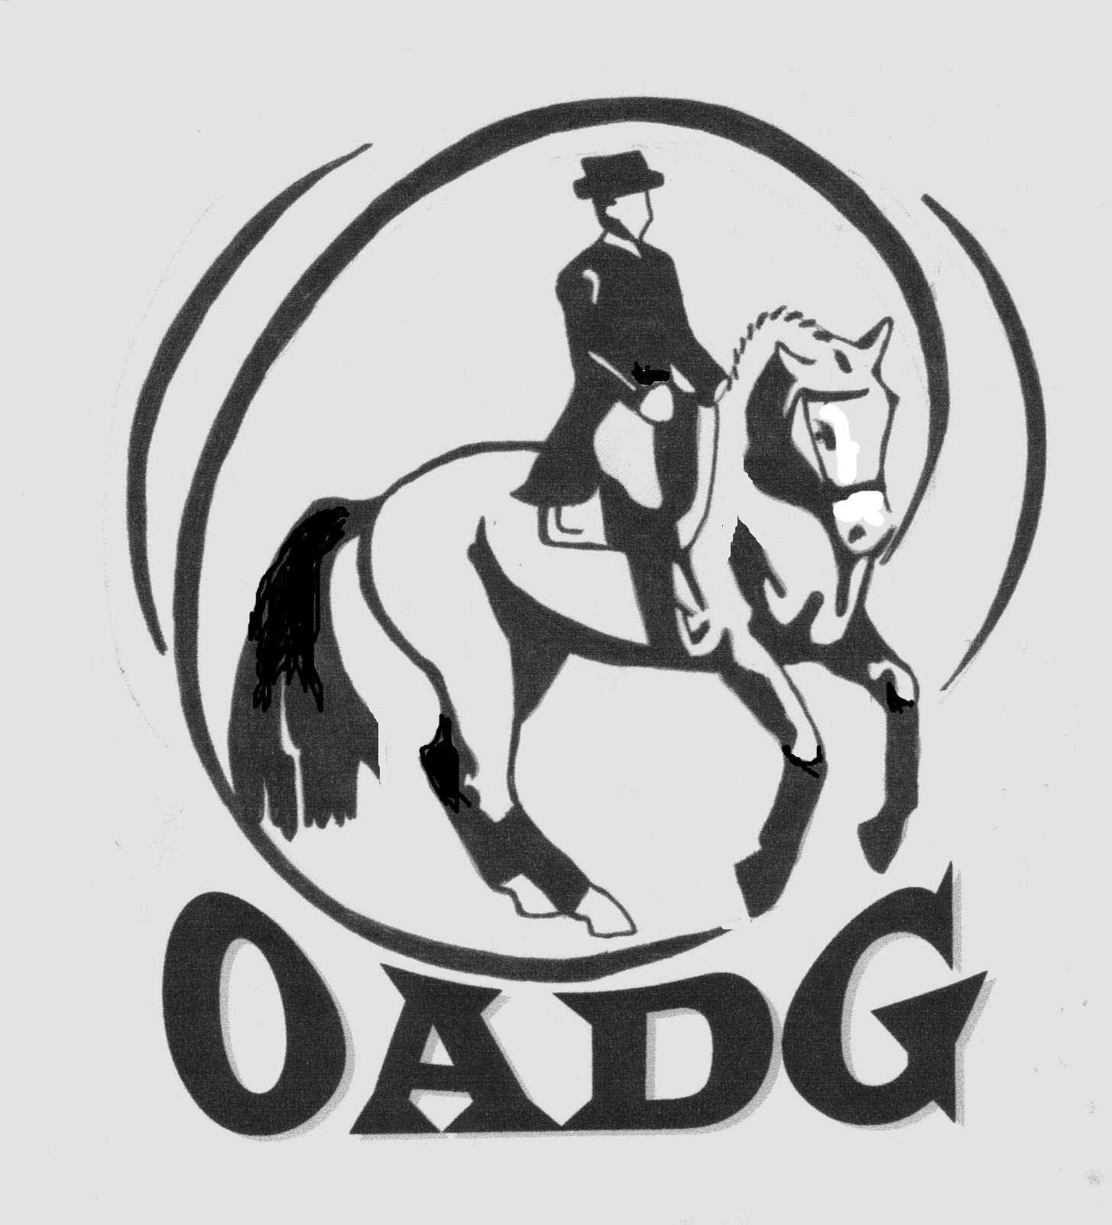

2015 OADG Awards Criteria

This document contains information regarding rules and eligibility requirements for the awards offered by the Ottawa Area Dressage Group. It is organized as follows:

- General Criteria
- ESD (Equine Skills Development aka Schooling) Awards
- Silver Awards
- Gold Awards
- FEI Awards (Gold and/or CDI Shows)
- OADG Special Awards

General Criteria

- To be eligible for a year-end award, both the Owner and Rider of the Horse must be OADG members by May 31, 2015. Membership by May 31 is deemed to be for the calendar year -- shows attended prior to joining will be retroactively reflected in a member’s official results.
- As part of its activities, the OADG sponsors prizes at local area shows in the following competition circuits: ESD (Schooling), Silver, Gold, and Platinum (note: Platinum or FEI/CDI shows are not always offered each season – check the show listings). The list of the “local” shows is posted on the OADG website.
- External shows are defined as those not sponsored by the OADG. (The more popular regional shows in Ontario/Quebec are listed on the OADG website.) Both “local” and “external” show scores are permitted for year-end award eligibility as set out in this detailed criteria -- see the specific competition circuit in the following tables. Please note the exception for ESD awards where no external scores are permitted.
- ONLY local show results will be tracked by the awards committee. Where an external score is permitted, an “External Scores Submission Form” is required to be submitted by the competitor.
- Interim results will be published on the OADG website. It is the competitors’ responsibility to verify their own results and notify the Awards Director as soon as possible of any errors or omissions.
- The team concept (horse and rider) applies for results tracking. If a horse or rider has a name change during the course of the season, the Awards Director must be notified.
- A unique Category (JR, AA, or O) also applies for results tracking. No combining of results will be permitted for horse-rider teams that switch from AA to O, for example, in mid-season. Additionally, a horse-rider team must actually ride in a class for the score to count for OADG awards. Add-on scores will be dropped from the tracking sheet.
- Team Challenge Award. One award is offered in each of ESD, Silver or Gold challenges. A team member is defined as a discrete horse/rider combination. A team member can participate on only one team; however a specific horse OR rider is eligible to participate on a different team. The deadline for declaring your team is May 31. Entries will be accepted after this date but must be received prior to all members competing.
- Scores from one circuit (i.e. Gold) cannot be counted towards another circuit (i.e. Silver).
- If more than one judge judges the same ride, the average of the scores of the judges will be counted as the official score.
- Only Equine Canada approved Dressage tests are eligible for OADG Awards. The only exceptions are the CADORA Walk/Trot tests used for W/T Rider and W/T Horse classes, and the Training Level Freestyle test as there is no Equine Canada freestyle available at this level.
- In all circuits, scores from “Test of Choice” classes will be counted towards Year End Awards provided they satisfy General Criteria #11 above, that they are clearly outlined in the prizelist and that, for tracking purposes, the show results indicate the test ridden. Scores from Special Request classes (defined as classes where the tests or levels are not published in the prizelist) will NOT be counted.
- The same horse-rider team may be awarded OADG Champion or Reserve Champion in the Silver and Gold circuits at the same level. This does not apply should the competitor qualify in the ESD circuit as well as Silver and/or Gold at the same level. In this case, the higher circuit trophy is awarded.
- Any required year end Award form and all trophy returns must be received by the OADG Awards Director by October 1, 2015. (Note: The forms deadline for ESD awards is extended to Oct 20, 2015 to accommodate one last show in the schedule.) Forms are available on the Awards page of the OADG website.
- Additional specific criteria for each circuit are outlined in the tables below.
ESD (aka Schooling) Series Awards

- To be eligible, a horse-rider team must have 3 scores >50%, from 3 different shows and a minimum 2 different sites.
- All shows must be local ESD (also known as Schooling) shows. Eligible shows are indicated as “local” on the show section of the website.
- Note: PeeWee, Young Horse and Team Challenge award forms are required for those specific awards.

Award | Level | Category
OADG | W/T Horse | JR, AA and O
 | W/T Rider | JR and AA
 | Equitation WT | All categories combined
 | Equitation WTC | All categories combined
 | Training | JR, AA and O
 | First | JR, AA and O
 | Musical Combination | All categories combined
PeeWee | All levels combined | PeeWee (12 yrs. & under)
Young Horse  (Horses 6 yrs. & under) | All levels combined  (excludes W/T &  Freestyle) | All categories combined
Team Challenge | All levels combined  (excl. Equitation & Musical) | JR/AA combined
Merit  3 scores ≥ 60%  From 3 different shows  Minimum 2 different sites | W/T Horse | JR and AA
 | W/T Rider | JR and AA
 | Training | JR and AA
 | First | JR and AA

Definitions of PeeWee for the Awards
- A competitor is a PeeWee until the end of the calendar year in which they reach the age of 12.

OADG Silver Series Awards
- To be eligible, a horse-rider team must have 3 scores >50%, from 3 different shows and a minimum 2 different sites.
- At least 2 of the shows must be local OADG sponsored EC Silver Shows.
- One score may be a non-local (or external) EC Silver Show elsewhere in Canada.
- Scores from the Eastern Silver Championships may be used and will be tracked by the OADG. Scores from the Western Silver Championships may be used, but must be reported as external scores.
- FEI Freestyles will be used for the Silver Freestyle Awards at the equivalent EC level.
- CADORA Freestyles will be used for the Training Level.
- Note: Young Horse, Team Challenge and External Scores Submission Forms are required where applicable.

Award | Level | Category
OADG | Training | JR, AA and O
 | First | JR, AA and O
 | Second | JR, AA and O
 | Third | JR, AA and O
 | Fourth | JR, AA and O
 | FEI Children, JR, Pony  & YR | All categories combined
 | FEI Advanced  (PSG, I1, I2) | AA and O combined
 | Training Freestyle | All categories combined
 | First Freestyle  (incl. FEI Children  Freestyle) | All categories combined
 | Second Freestyle  (incl. FEI Pony Freestyle) | All categories combined
 | Third Freestyle  (incl. FEI JR Freestyle) | All categories combined
 | Fourth Freestyle  (incl. FEI YR Freestyle) | All categories combined
Young Horse  (Horses 6 yrs. & under) | All levels combined  (excludes Freestyle) | All categories combined
Team Challenge | All levels combined  (excl. Freestyle, incl. W/T) | All categories combined
Merit  3 scores ≥ 65%  From 3 different shows  Minimum 2 different sites | Walk/Trot | JR, AA and O
 | Training | JR, AA and O
 | First | JR, AA and O
 | Second | JR, AA and O
 | Third | JR, AA and O

OADG Gold Series Awards

- To be eligible, a horse-rider team must have 3 scores >50%, from 3 different shows and a minimum 2 different sites.
- At least one of the shows must be an OADG sponsored local EC Gold Show.
- Two scores may be from non-local (or external) Gold Shows elsewhere in Canada or USA.
- Note: Young Horse, Team Challenge and External Scores Submission Forms are required where applicable.

Award | Level | Category
OADG | Training | JR, AA & O
 | First | JR, AA & O
 | Second | JR, AA & O
 | Third | JR, AA & O
 | Fourth | JR, AA & O
 | First Level Freestyle | All categories combined
 | Second Level Freestyle | All categories combined
 | Third Level Freestyle | All categories combined
 | Fourth Level Freestyle | All categories combined
Young Horse  (Horses 6 yrs. & under) | All levels combined  (excludes Freestyle) | All categories combined
Team Challenge | All levels combined  (excl. Freestyle, incl. W/T) | All categories combined
Merit  3 scores ≥ 65%  From 3 different shows  Minimum 2 different sites | Walk/Trot | JR, AA and O
 | Training | JR, AA and O
 | First | JR, AA and O
 | Second | JR, AA and O
 | Third | JR, AA and O
 | Fourth | JR, AA and O

OADG FEI Awards for FEI classes at Gold or CDI Shows

- To be eligible, a horse-rider team must have 3 scores >50%, from 3 different shows and a minimum 2 different sites.
- At least 1 of the shows must be an OADG sponsored local EC Gold show offering FEI classes or an FEI CDI Show.
- Two scores may be a non-local (or external) EC Gold Show or CDI elsewhere in Canada or USA.
- Note: An External Scores Submission Form is required where applicable.

Award | Level | Category
FEI at Gold & CDI shows | Pony (Individual & Team) | All categories combined
 | Pony Freestyle | All categories combined
 | Children (Individual &  Team) | FEI Children
 | Junior (Individual & Team) | JR
 | Junior Freestyle | JR
 | Young Rider (Individual &  Team) | YR
 | Young Rider Freestyle | YR
 | Prix St Georges | AA
 | Prix St Georges | O
 | Intermediare 1 | AA and O combined
 | Intermediare 2 | AA and O combined
 | Intermediare Freestyle | AA and O combined
 | Grand Prix & Grand  Prix Special | AA and O combined
 | Grand Prix Freestyle | AA and O combined
 | FEI 4 Year Old | AA and O combined
 | FEI 5 Year Old | AA and O combined
 | FEI 6 Year Old | AA and O combined

OADG Special Year-End Awards for OADG Members

Dr. Brian Mills Award
Awarded to the OADG outstanding Junior Rider at the Gold, CDI or FEI level.
Names are put forward by the OADG Board.
Award is determined by the Dr. Brian Mills Memorial Fund and announced at
the Year-End Awards Banquet.

Horse Owner of the Year Award
OADG member riders may nominate an OADG member who is a horse owner and provides a horse for
competition.
Submission of a Horse Owner of the Year Award Form is required.
Decision is by voting of the OADG Board.
Volunteer of the Year Award
OADG members may nominate any OADG member.
Submission of a Volunteer of the Year Award form is required.
Decision is by voting of the OADG Board.
Senior Rider of the Year Award
Sum of top 3 marks by an Open or AA horse-rider team where the rider is ≥ 55 years.
Scores must all be from the same circuit and follow the requirements as set out for the year-end awards for that that circuit.
Submission of a Senior Rider of the Year Award form is required.
Para-Equestrian Rider of the Year Award
Sum of top 3 marks >50% by a Para-Equestrian Rider.
Scores can be from 3 different shows, any show circuit and any level, providing two are
from local shows.
The scores must be from at least 2 different sites.
Submission of a Para-Equestrian Rider of the Year Award form is required.
Other special awards decided by OADG Board.
OADG Year-end special award to 2015 Eastern Division Champions & Freestyle champions.
OADG Year-end special award to 3 highest scores overall in each show circuit.
OADG Annual Special Achievement Awards

