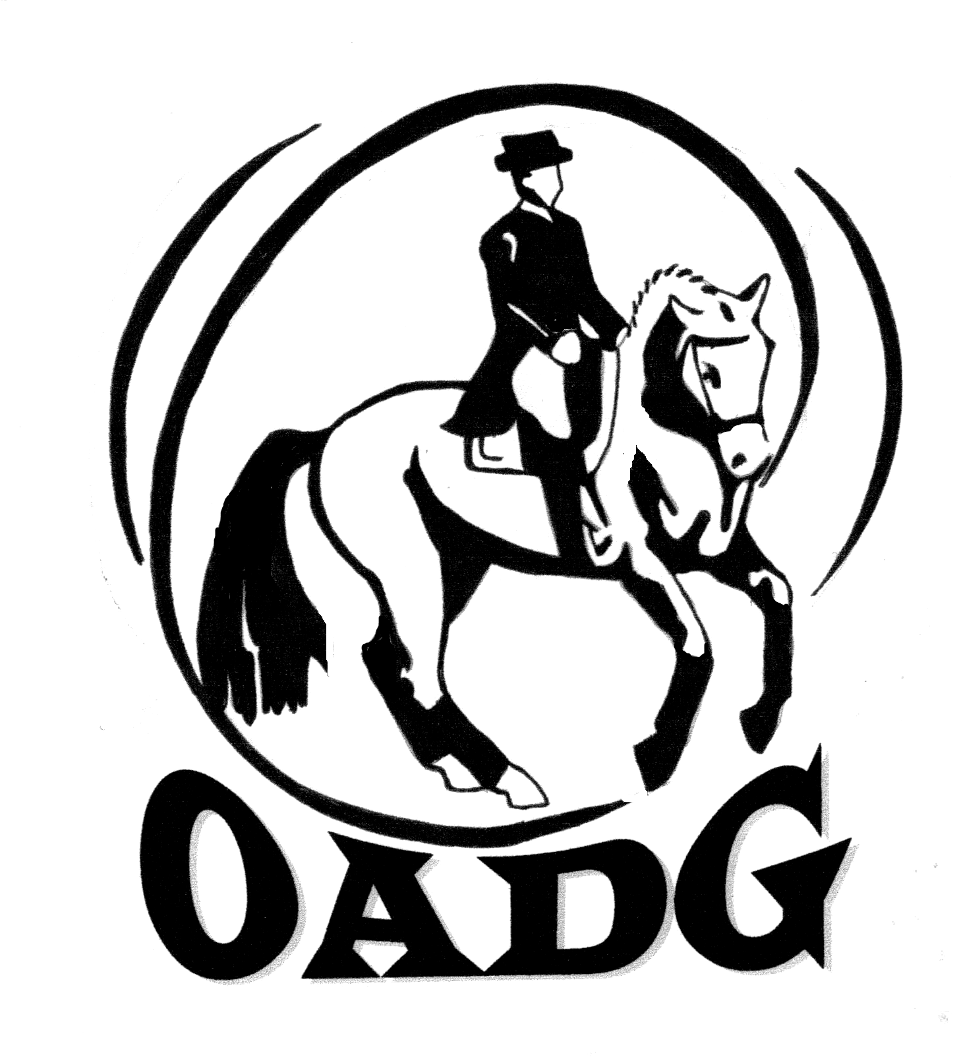

Ottawa Area
Dressage Group

Presents the

2016 Annual Awards Banquet

Saturday November 26, 2016

Tudor Hall

OADG Special Cash Awards (highest 3 scores overall)
- OEF SCHOOLING JR : Margot Guy & Make A Wish
- OEF SCHOOLING AA: Emily Tichon & Margo
- SILVER JR: Chloe Dupont & Darlin’
- SILVER AA: Jackie Naida & Conquest
- SILVER OPEN: Kerri Wickware & Dibbrich
- GOLD JR: Karina Cudahy & Sovereign
- GOLD AA: Anouk Desaulniers & Soulstar Ste-Rose
- GOLD OPEN: Simone Williams & Dakota
Special Achievement Award Winners
Lindsay Cooper-Kelly - 2016 NAJYR Championships
Nicole Babich-Morin - 2016 NAJYR Championships
Elsie Reford - 2016 Lendon Gray Youth Dressage Festival
Lucie Reford - 2016 Lendon Gray Youth Dressage Festival
Karina Cudahy - Commitment to Horsemanship
Senior Rider Award – Anthony Jackson Memorial Renroc Farm Trophy
Shelia Trusdale
Volunteer Award – Balanced Planning Financial Group Trophy
Cathy Gordon
Horse Owner of the Year - Zachary Ball Trophy
Marion Bailey-Canham
Para-Equestrian Rider of the Year -
The “Noble Bay” Trophy

Karina Cudahy

The Madison Crich Memorial Adult Amateur Award
Diane Forbes

The Dr. Brian Mills Memorial Fund Award to the Outstanding Junior Rider in National Competition
Devlin Abergel-Preston

OADG Trophies for FEI Dressage

FEI Children Individual and Team - Dorothy Leggett Trophy
Champion: Kiara Williams-Brown & Popcorn
FEI Junior Individual and Team - Private Benjamin Trophy Christina Dubé
Champion: Lindsay Cooper Kelly & Gizmo
FEI Junior Freestyle - Friends of the Park Trophy
Champion: Lindsay Cooper Kelly & Gizmo

FEI Young Riders Individual and Team - Dick, Marilyn & Kerri McGregor/Hélène Dumas Trophy
Champion: Nicole Babich-Morin & Deniros Tyme
Reserve: Nicole Babich-Morin & Rumble

FEI Prix St. Georges AA – Don Deimos Trophy
Champion: Caroline George & Tundra

FEI Prix St. Georges Open – Abergel-Preston Family
Champion: Robin-Lynn Brent & Biolek
Reserve: Sian Fernandez Thomas & The X Factor

FEI Advanced (Intermediaire) Freestyle - In Memory of Dr. Edward Atack Trophy
Champion: Caroline George & Tundra
FEI Grand Prix & Grand Prix Special – Gilles Cordier Trophy
Champion: Simone Williams & Farley
FEI Grand Prix Freestyle – Patanal Farm Trophy
Champion: Simone Williams & Farley

FEI 4 Year Old – Claire Smith Trophy sponsor Zigman Metals
Champion: Danika Guertin-Pierson & Delgado

OADG Trophies for OEF Schooling Dressage
Walk/Trot Horse PW/JR – In Memory of Donald Bradley, Spirit of the Silver Dart Trophy
Champion: Margot Guy & Make A Wish
Reserve: Rebecca Walker & Kira
Third: Julia Dings & Cookies N’Cream
Walk/Trot Horse Open – The Johnny Lebeau Trophy
Champion: Nathalie Burke & Royale’s Registrar
Reserve: Celine Hutchison Majerus & Mr Cinder
Walk/Trot Rider PW/JR – Dressage Champion, OADG Trophy
Champion: Gaby Distefano & Paint Misbehavin’
Reserve: Katie Horner & Scootie the Luvbug
Walk/Trot Rider AA – The Horse People Trophy
Champion: Emily Tichon & Margo

Walk/Trot Equitation – Introductory Dressage Equitation Dhartana Trophy
Champion: Margot Guy & Make A Wish
Emily Tichon & Margo
Reserve: Katie Horner & Scootie the Luvbug
Third: Julia Dings & Cookies N’Cream

Walk/Trot/Canter Equitation – The Georgia Satin Trophy
Champion: Julia McIntosh & Cheeky x’s 2
Jennifer Deschamps & Soul Man
Reserve: Stephanie Glanville & Tequilia Sunrise
Third: Sophie Vermeirre & Snickers
Milena Hayman & Cocoa

Training Level PW/JR – The Steps Impressive Trophy
Champion: Sophie Vermeirre & Snickers
Reserve: Aaliyah Hage-Hassan & D’Soda Pop
Third: Milena Hayman & Cocoa

Training Level AA – Heroncrest Stables Trophy
Champion: Jennifer Deschamps & Soul Man
Reserve: Jessica Messier & Registered Trademark
Third: Lindsay Brown & Redemption

First Level PW/JR – OADG Trophy
Champion: Megan Donnelly & Boomer
Reserve: Sophie Vermeirre & Snickers
Third: Amber Sahota & Aurora Borealis

First Level AA - The Bitter Sweet Nugget Trophy
Champion: Jennifer Riley & Kasper
Reserve: Lindsay Brown & Redemption

Musical Combination – The Littlewood Girls Memorial Trophy
Champion: Jessica Messier & Registered Trademark
Reserve: Jennifer Riley & Kasper

OEF Schooling Young Horse Award – Dorothy Leggett Trophy
Champion: Royale’s Registrar
Owner: Emily Bertrand, Rider: Nathalie Burke
Reserve: Mr Cinder
Owner & Rider: Celine Hutchison-Majerus
Third: Cookies N’Cream
Owner & Rider: Julia Dings

OADG Pee Wee Award – The ‘Eye Spy’ Trophy
Heroncrest Stables
Champion: Julia Dings & Cookies N’Cream
Reserve: Trinity Walkling & Forest Lane Sweet Apple Scrunchions
Third: Julia McIntosh & Cheeky x’s 2
Gaby Distefano & Paint Misbehavin’

OADG Awards of Merit for OEF Schooling Dressage
(3 scores of 60% or better at a single level from each of 3 shows – PW/JR & AA)
- Gaby Distefano & Paint Misbehavin’
- Emily Tichon & Margo
- Julia Dings & Cookies N’Cream
- Margot Guy & Make a Wish
- Nathalie Burke & Royale’s Registrar
- Celine Hutchison-Majerus & Mr Cinder
- Julia McIntosh & Cheeky x’s 2
- Trinity Walkling & Forest Lane Sweet Apple Scrunchions
- Sophie Vermeirre & Snickers
- Aaliyah Hage-Hassan & D’Soda Pop
- Abigayle Gaumont & Alibi
- Milena Hayman & Cocoa
- Elodie Lebeau & La Dolce Vita
- Lindsay Brown & Redemption
- Jennifer Deschamps & Soul Man
- Stephanie Glanville & Tequila Sunrise
- Erin Foisey & Ella
- Jessica Messier & Registered Trademark
- Courtney Cavanagh & Acts of Light
- Megan Donnelly & Boomer

ESD OADG Team Challenge
Centaur Riding School
Emily Tichon & Margo
Abbey Gaumont & Alibi
Milena Hayman & Cocoa

OADG Trophies for Silver Dressage

Training Level JR – Robingreen Farms Trophy
Champion: Chloe Dupont & Darlin’
Reserve: Steacy Meghan & Sargeant Pepper
Third: Malyssa Morin & Dapple or Nothing

Training Level AA – The Friends of the Nepean National Equestrian Park Trophy
Champion: Julie Tourangeau & Tazzelle
Reserve: Jennifer Moore & McCarry Me Home

Training Level Open – Centaur Riding School Trophy
Champion: Megan Jenner & So Much to Offer
First Level JR - Dr. and Mrs. E. A. Atack Trophy
Champion: Emma Richardson & Sokit2ya

First Level AA – John R. Allan Memorial Trophy
Champion: Jackie Naida & Conquest
Reserve: Tamara Sone & Wendell
Third: Carolyn Allen & Kavita

First Level Open – Mrs. Herta Blaeske Trophy
Champion: Kerri Wickware & Dibbrich
Reserve: Kaylee Mashinter & Korsteele
Third: Zoe Laframboise & Kahlua
Second Level JR - P. Dauntless Memorial Trophy
Champion: Erika Kirkham & Havoc

Second Level AA – Spindrift Farm Trophy
Champion: Jenna Mayhew & Kinsale
Reserve: Kiki Baggerman-Webster & Froeya
Third: Emily Deslauriers & Aadonis

Second Level Open – Kintay Limited Trophy
Champion: Nicole Allen-Dings & Noah

Third Level AA – OADG Trophy
Champion: Gail Armstrong & Jewel of the Nile
Reserve: Marcia George & Faustina

Third Level Open – Queenswood Stables Trophy
Champion: Nicole Allen-Dings & Leandro
Fourth Level Open - OADG Trophy
Champion: Carolyn Rathwell & Dragon

Second Level Freestyle & FEI Pony Freestyle - Shieldhedge Equestrian Farm Trophy
Champion: Kiki Baggerman-Webster & Froeya

Silver Young Horse Award – Almonte Quick Print Trophy
Champion: Darlin’
Owner: Roz Johnson, Rider: Chloe Dupont
Reserve: Tazzelle
Owner & Rider: Julie Tourangeau

OADG Awards of Merit for Silver Dressage
(3 scores of 65% or better at a single level from each of 3 shows)
- Chloe Dupont & Darlin’
- Tamara Sone & Wendall
- Jackie Naida & Conquest
- Kerri Wickware & Dibbrich
- Jenna Mayhew & Kinsale

Silver OADG Team Challenge
No Champion for 2016

OADG Trophies for Gold Dressage

Training Level JR – Kars Riding School Trophy
Champion: Karina Cudahy & Sovereign
Reserve: Katie Bell & Doctor Love
Third: Amanda Maloney Dubé & Montego Bay

Training Level AA – Zachariah Trophy
Kiki Baggerman-Webster
Champion: Tara Freel & Solaris
Reserve: Brigitte Lalonde & For Fun
Third: Sonya Lipsett-Rivera & Dudley Do Right

Training Level Open – Twin Pines Equestrian Centre Trophy
Champion: Simone Williams & Dakota
Reserve: Kari Ross & Ruinartattack

First Level JR – Snipper Financial Planning Inc. Trophy
Champion: Katie Bell & Doctor Love
Reserve: Kiara Williams-Brown & Popcorn
Third: Noemi Morris & I Won An Oscar

First Level AA – Mac’s Delivery Service Trophy
Champion: Anouk Desaulniers & Soulstar Ste-Rose
Reserve: Carolyn Allen & Kavita

First Level Open – Robichaud Trophy
Champion: Michelle Pyper & Charlie’s Angel
Second Level JR - Mac’s Delivery Service Trophy
Champion: Kiara Williams-Brown & Popcorn

Second Level AA – Mac’s Delivery Service Trophy
Champion: Roz Johnson & Darlin’

Second Level Open – Tiziana Trophy
Champion: Tiffany Randall & Halladay
Reserve: Michelle Pyper & Charlie’s Angel
Third Level JR - Mac’s Delivery Service Trophy
Champion: Devlin Abergel-Preston & Perpetual Motion
Reserve: Devlin Abergel-Preston & Wakeup

Third Level AA – Queenswood Stables Trophy
Champion: Sheila Trusdale & Regala
Reserve: Alison Sims-vanZyl & Charm
Third: Julia Werneberg & Sir Matteo

Third Level Open – Oxford Ridge Stables Trophy
Champion: Sian Fernandez Thomas & Soraya
Fourth Level AA – The Chocolate Soldier Trophy,
Cathy Gordon
Champion: Diane Forbes & Ginger

Fourth Level Open – Helen M. Chamberlin Trophy
Champion: Daniel Kehres & Hollywood
Reserve: Abdulla Patterson & Buckley

Third Level Freestyle - Spiritwood Boarders Trophy
Champion: Julia Werneberg & Sir Matteo

Fourth Level Freestyle - Rideauwood Farm Trophy
Champion: Diane Forbes & Ginger
Gold Young Horse Award – Rock Ridge Sport Horse
Champion: Delgado
Owner: Caroline Lanthier, Rider: Danika Guertin-Pierson
Reserve: Soulstar Ste-Rose
Owner & Rider: Anouk Desaulniers

OADG Awards of Merit for Gold Dressage
(3 scores of 65% or better at a single level from each of 3 shows)
- Karina Cudahy & Sovereign
- Katie Bell & Doctor Love
- Courtney McHugh & Watch Me Dance
- Tara Freel & Solaris
- Brigitte Lalonde & For Fun
- Sonya Lipsett-Rivera & Dudley Do Right
- Simone Williams & Dakota
- Anouk Desaulniers & Soulstar Ste-Rose
- Carolyn Allen & Kavita
- Devlin Abergel-Preston & Perpetual Motion
- Sian Fernandez Thomas & Soraya
- Daniel Kehres & Hollywood
- Tiffany Randall & Halladay

Gold OADG Team Challenge
The Queenswood Queens
Simone Williams & Dakota
Kiara Williams-Brown & Popcorn
Katie Bell & Doctor Love

~ Special Door Prizes ~

Sponsors

Cadora National (Cadora Inc.) dressagegames@aol.com
Equestrian Canada, www.equestrian.ca, 1-866-282-8395
Ontario Equestrian Federation, www.horse.on.ca, 1-877-441-7112
Ontario Federation of Agriculture, Guelph, 1-800-668-3276
Ottawa Area Dressage Group, www.ottawadressage.ca, 613-821-6206
Apple Saddlery, Innes Rd., 613-744-4040, 1-800-867-8225
Brent’s Farrier Works, www.stonemeadowstable.com
Circle J Ranch, Metcalfe, chicksatthereins@hotmail.com, 613-821-2437
Clarmell Farms Bakery, Manotick, http://www.clarmellfarms.com,
613-826-2959
Col. A. Frank Cooper
The Co-operators, William McDonald, Manotick, 613-692-5070
Crazy Carousel Tack Shop, Rigaud, Quebec, 1-450-458-2430
Dan Morris, Royal Lepage Team Realty, 613-825-7653
Cheryl Denault, RODAN & FIELDS, 613-668-5977
ECOGOLD HT Ecologic Product Ltd., www.ecogold.ca, 1-514-342-5893
Embellish Horse, Kathleen Cullen, kcullen@live.ca
Emerald Links Golf & Country Club, Manotick Station, 613-822-6353
Encore Equestrian Tack and Apparel, Hwy 43, Merrickville, www.encoreequestrian.com, 613-269-Tack (8225)
Greenhawk Harness & Equestrian Supplies, Nepean, 613-225-9900
Hawley’s Corners Gift Shop, Metcalfe, 613-821-1332
ISOLARA Solar Power, 613-738-2646
Kate’s Kreations, Kate Sim, 613-285-4318
Kicking Horse Media, http://kickinghorsemedia.ca, 613-257-5145
Lone Star Texas Grill, Lemieux St., Gloucester, 613-742-9378
Maple Lane Equestrian Trailers, Smith Falls, 1-866-235-3401

Sponsors…

Catherine Maguire, Almonte
Metcalfe Golf & Country Club, Metcalfe, 613-821-2701
Northern Equestrian Centre, A. Brebner, Osgoode, 613-229-5547
Oakhurst Farm, Joan Allum and Mark Nelson, www.oakhurstfarm.ca
Peggy and Pat McQuaid, Stittsville
Rainbow Ridge Ranch, S. Curtis & L. Maltby, Greely, 613-821-2939
RBC Royal Bank, Metcalfe Branch, Pauline Drummond, 613-821-2021
Red Dot Café, Market Square, Osgoode, 613-826-0552
Rocking Horse Stable, Rockland, Val and Jim Everson, 613-488-3066
Rockland Textiles Inc., www.rocklandtextiles.com, 613-526-0333
Rooney Feeds Ltd., Kemptville, 613-258-1567 & Iroquois, 613-652-4382
Rowland Leather & Merrickville Suites, 1-800-806-6983, www.rowlandleather.com
Russell Equine Veterinary Services, www.russellequine.com,
613-445-3521, Dr. Carole Michon and Dr. Garth Henry
Sandridge Saddlery, Ste. Lazare, 1-800-520-8225
Schleese Saddlery Service Ltd., www.schleese.com, 1-800-225-2242
Stephen Morris, Cert.Journeyman Farrier, Oxford Mills, 613-258-4417
Stittsville Trailer and Auto Sales Inc., Orville Hartwick, 613-836-5555
Stone Meadows Inc., Robin-Lynn and Jon Brent, www.stonemeadowstable.com, 613-295-9147
Surgenor Barrhaven, Carney Howe, 1-866-692-3554
Susan and Terry Otto, Metcalfe
Valley Vet Clinic, Carleton Place, equine@valleyvet.ca,
Dr. Evangeline Wiens, 613-257-3202

Trophies Not Awarded for 2016
OADG gratefully acknowledges the sponsorship of our year-end trophies. The following trophies were not awarded for the 2016 competition season.

OADG Trophies for Schooling Dressage
- Walk/Trot Horse AA - The Icy (Andante) Trophy
- Training Level Open - Appleton Pony Trophy
- First Level Open - Claire Smith Trophy

OADG Trophies for Silver Dressage
- Fourth Level JR - OADG Trophy
- Fourth Level AA - Dorothy Leggett Trophy
- FEI Prix St. George - Glace Bay Memorial Trophy
- Training Level Freestyle - Patricia Blaeske Memorial Trophy
- First Level Freestyle & FEI Children Freestyle - David and Carolyn Rees Potter Phantom Farm
- Third Level Freestyle & FEI Junior Freestyle - OADG Trophy
- Fourth Level Freestyle & FEI Young Rider Freestyle - Forio Memorial Cup
- Eastern Ontario Silver Championships Freestyle Champion - OADG & Claire Smith Trophy

OADG Trophies for Gold Dressage
- First Level Freestyle - Col. T.A.G. Moore Memorial Trophy
- Second Level Freestyle - Pat James Memorial Trophy Patanal Farm

OADG Trophies for FEI Dressage
- FEI Pony Individual and Team - Tony Thompson & Jenny Jackman Trophy / Spindrift Farm Trophy
- FEI Pony Freestyle - The Dust Family in memory of Rapide
- FEI Young Rider Freestyle - Dr. Brian Mills Memorial Trophy, Judy, Joanna & Emily
- FEI Intermediaire 1 - Diana Trafford Trophy
- FEI Intermediaire 2, A, B - Centaur Riding School Trophy
- FEI 5 Year Old - Fleggstone Farm Trophy
- FEI 6 Year Old - James Rigden Trophy

