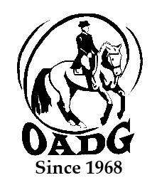

2019 OADG Horse Owner of the Year Submission Form

Must be submitted by October 11th, 2019

You may email this form to save paper & time

Do you wish to recognize the owner of the horse that you are competing on? The purpose of this award is to nominate a unique and supportive horse owner - who through their ownership of the horse, have demonstrated a commitment to the sport of Dressage and furthering another’s equestrian skills, without any benefit to themselves. In 2009, Zachary Ball presented the inaugural trophy to Sarah McIlwham, the owner of the horse he rode. Riders may nominate an OADG member who is a horse owner and provides a horse for competition.

Criteria:
- Both riders and owners must be OADG members.
- A small essay must be written by the rider defining why the owner deserves such an award.
- The owner must have assisted the rider with obtaining their personal goals for this year.

Name of Owner: _____________________________________________

Name of Rider: ______________________________________________

Name of Horse: ______________________________________________

Essay: (please use another page or include in the body of email if submitting form by email)

Rider’s Signature: ____________________________________________

E-mail: _____________________________________________________

Contact Phone Number: _______________________________________

Mail to: Or email to: awards@ottawadressage.ca
(signature not required)
Tami O’Dette, OADG Awards Director
790 Dunloe Ave.
Ottawa, ON
K1K 0K4

This form must be received by the deadline.

