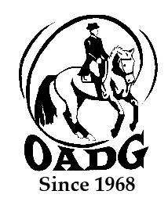

2021 OADG Team Challenge Team Name Declaration Form

Team results close on October 30th, 2021

You may email this form to save paper & time

This form is required if you are applying for the Team Challenge Award.

OADG will allow a team to be declared with four (4) horse and rider combinations - but only the top scores from three (3) rider/horse combinations can be submitted for awards.

Please see full criteria details on the OADG website www.ottawadressage.ca

The deadline for declaring your team is April 1st. Entries will be accepted after this date but must be received prior to all members competing.

Name of Team: ________________________________________________________________________

Show Circuit: (circle one) ESD/Schooling Silver Gold

Names of Team Members
Rider | Horse | Indicate  JR, AA or O

Contact Signature: ____________________________________________________________

Contact E-mail: _______________________________________________________________

Contact Phone Number: ________________________________________________________

Mail to: Or email to: awards@ottawadressage.ca
(signature not required)
Tami O’Dette, OADG Awards Director
790 Dunloe Ave.
Ottawa, ON K1K 0K4
This form must be received by the deadline.

