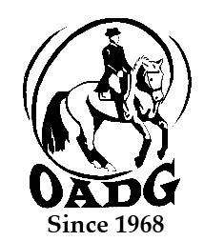

**2024 OADG External Score Submission Form   
Must be submitted by deadline on OADG website**

***You may email this form to save paper & time***

This form **is not required** if you are showing at any local show sponsored by the OADG: Silver, Gold or Platinum (FEI/CDI).

This form **is required** if you have an external show score to report from Silver or Gold circuits.

If you are submitting scores for the Young Horse Award, please use the form entitled “Young Horse Award Form”.

Circuit (underline or circle one): Silver Gold FEI

Division (underline or circle one): Junior AA Open

Level:__________________________________ (Walk/Trot Training, First, Second.....)

Name of Rider: ______________________________________________

Name of Owner: _____________________________________________

Name of Horse:______________________________________________

**Criteria – Please see full criteria details on website www.ottawadressage.ca**

**Results**: Please list your eligible external score (to 3 decimal places).

If your ride was judged by more than one judge, please submit only the combined score.

**Include website where scores can be verified (preferred method) or attach copies of the test papers.**

|  |  |  |  |  |  |
| --- | --- | --- | --- | --- | --- |
| **Show Location** | **Date** | **Class** | **Judge(s)** | **Score** | **Website** |
|  |  |  |  |  |  |

Rider’s Signature: ____________________________ E-mail: _______________________________________

Contact Phone Number: ________________

**Mail to: Or email to:** [awards@ottawadressage.ca](mailto:awards@ottawadressage.ca)

(signature not required)

Natalie Savoie

5736 Dunning Rd

Navan, ON

K4B 1J1

*Form must be* ***received*** *by the deadlines.*