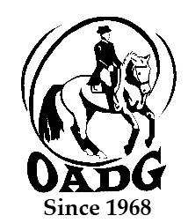

# 2024 OADG Para-Equestrian Award Submission Form Must be submitted by deadline on OADG website

***You may email this form to save paper & time***

This form **is required** if you are applying for the Para-Equestrian Award. Para-Equestrians must be declared by Equine Canada.

Name of Rider: ______________________________________________

Name of Owner: _____________________________________________

Name of Horse:______________________________________________

**Criteria – Please see full criteria details on website** [**www.ottawadressage.ca**](http://www.ottawadressage.ca)

**Results**: Please list your top three (3) eligible results (to 3 decimal places).

**If any scores are from external shows, include website where scores can be verified (preferred method) or attach copies of the test papers for those scores.**

|  |  |  |  |  |  |
| --- | --- | --- | --- | --- | --- |
| **Show Location** | **Date** | **Class** | **Judge(s)** | **Score** | **Website** |
|  |  |  |  |  |  |
|  |  |  |  |  |  |
|  |  |  |  |  |  |

Sum of top three(3) eligible scores: ____________

Rider’s Signature: _________________________ E-mail: _______________________________________

Contact Phone Number: ___________________________

**Mail to: Or email to:** [awards@ottawadressage.ca](mailto:awards@ottawadressage.ca)

*(signature not required)*

Natalie Savoie

5736 Dunning Rd

Navan, ON

K4B 1J1

*This form must be* ***received*** *by the deadline.*