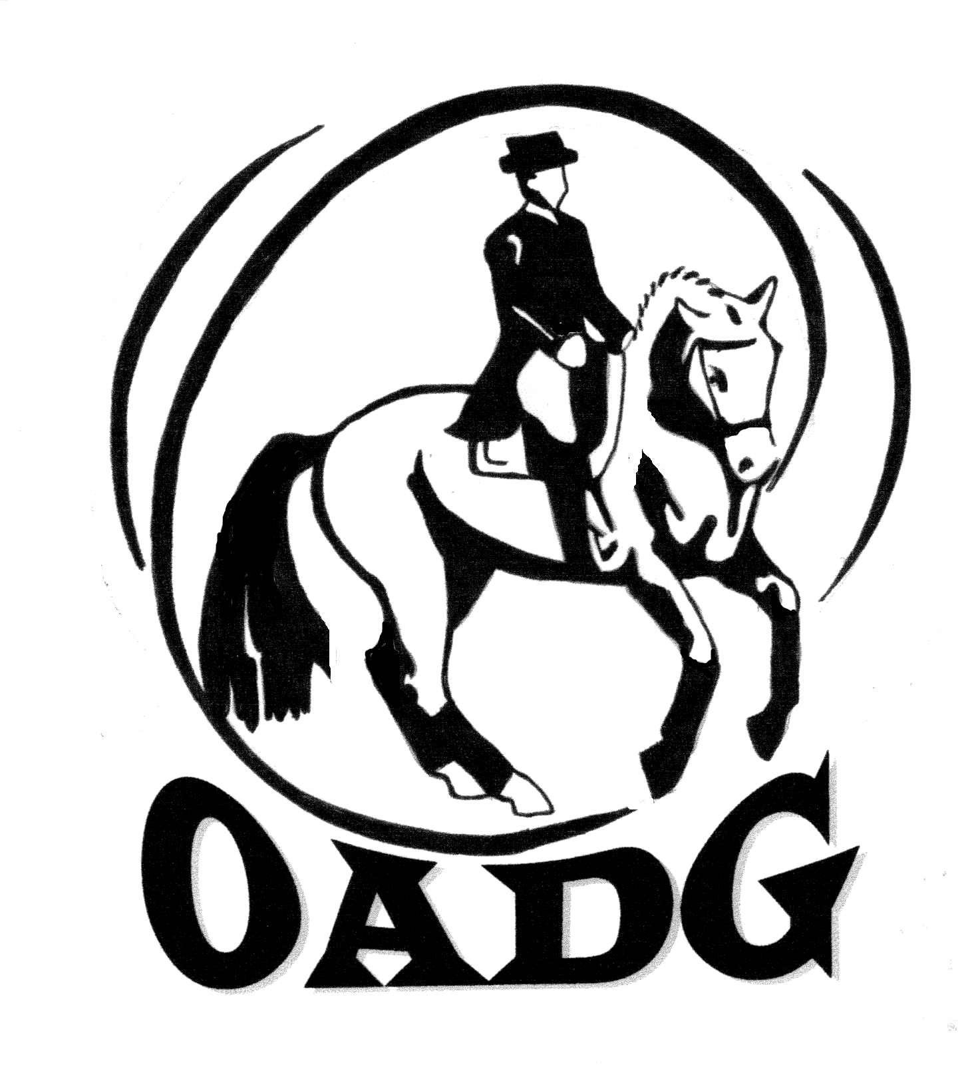
OTTAWA AREA DRESSAGE GROUP

JOIN US FOR THE OADG ANNUAL AWARDS BANQUET

When: Saturday, November 22, 2014
Cocktails: 5:30 p.m. (cash bar)
Dinner: 6:30 p.m. (cash bar)

Where: Hellenic Meeting and Reception Centre
1315 Prince of Wales Drive, Ottawa, Ontario

Tickets: $38 (adult) and $20 (children 10 and under)
(Make cheque payable to OADG)
(Deadline to order tickets: Saturday, November 15, 2014)
(Drinks are not included in ticket price. Cash bar is available at the event)

Contact: Marie-Christine Boucher at 613-573-0075 or 819-319-3202 (Banquet Director)
Email: banquet@ottawadressage.ca

Special guest speaker: Shirley Guertin (Lendon Gray ‘Dressage for Youth Festival’)

Map to banquet venue:

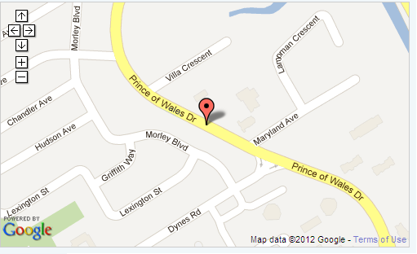

www.hellenicottawa.ca

If you have special needs (food allergies or handicap accessibility),
please contact the Banquet Director to discuss requirements.

