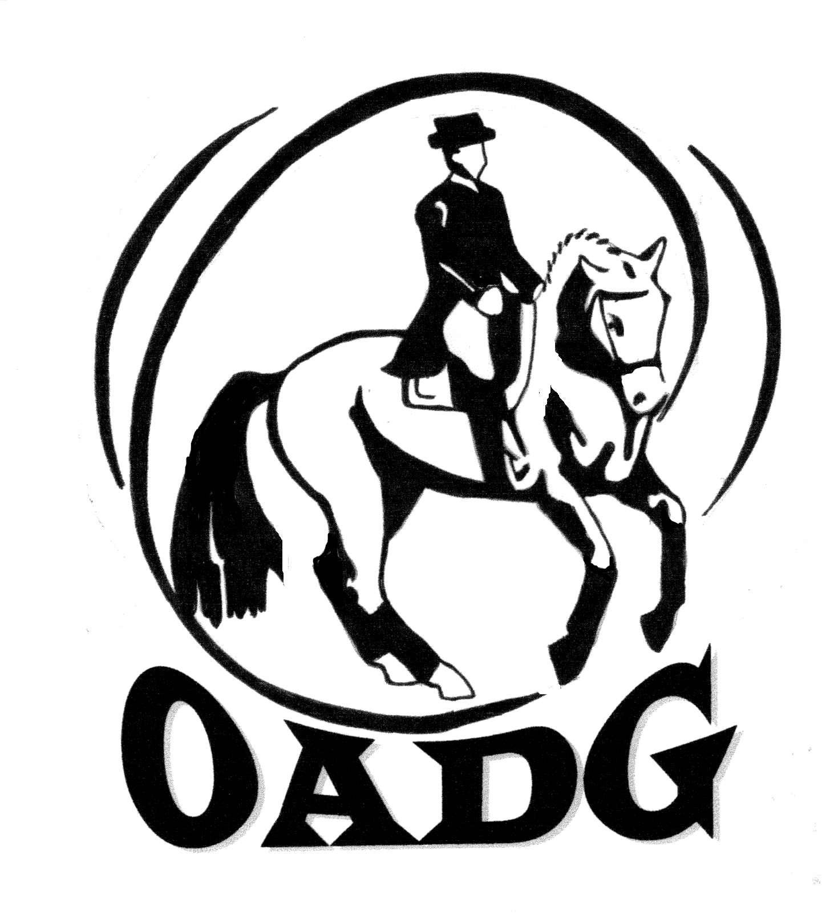
OTTAWA AREA DRESSAGE GROUP

JOIN US FOR THE OADG ANNUAL AWARDS BANQUET

When: Saturday, December 5, 2015
Cocktails: 5:30 p.m. (cash bar)
Dinner: 6:30 p.m. (cash bar)

Where: Hellenic Meeting and Reception Centre
1315 Prince of Wales Drive, Ottawa, Ontario

Tickets: $40 (adult) and $20 (children 10 and under)
Payable by cheque payable to OADG
OR NEW ***E-TRANSFER***
(email: Laura Lee Brenneman at oadg2012@gmail.com to make arrangements)

(Deadline to order tickets: Saturday, November 21, 2015)
(Drinks are not included in ticket price. Cash bar is available at the event)

Contact: Heather Kelly at 613-795-7997 (Banquet Director)
Email: banquet@ottawadressage.ca

We are pleased to announce our Special guest speaker:
Brittany Fraser, a member of the Pan Am Games Canadian Dressage Team.

Map to banquet venue:

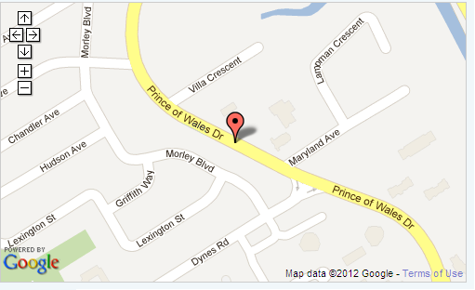

www.hellenicottawa.ca

If you have special needs (food allergies or handicap accessibility),
please contact the Banquet Director to discuss requirements.

