OTTAWA AREA DRESSAGE GROUP

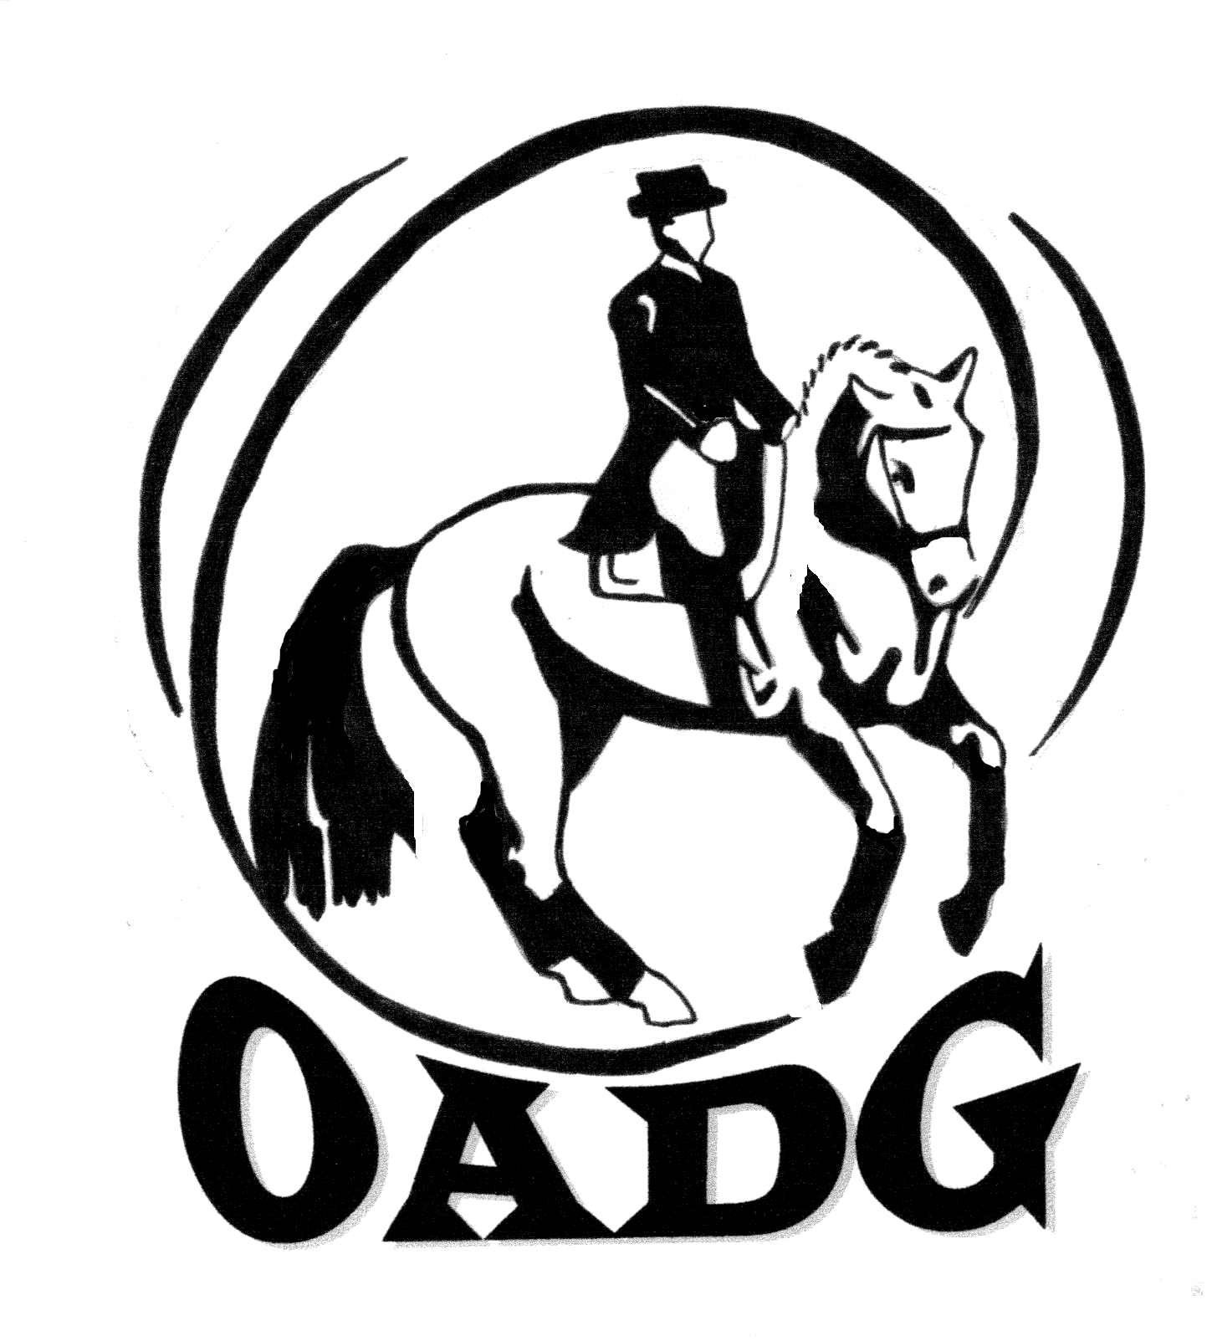
ANNUAL AWARDS BANQUET

Saturday November 17th 2012

Hellenic Meeting and Reception Centre
1315 Prince of Wales Dr., Ottawa, On

Cocktails: 6:00 p.m. (CASH BAR)
Dinner: 6:30 p.m. (CASH BAR)

Tickets: $42.00 per person
($23.00 – children 10 and under)
(Make cheques payable to OADG)
(Deadline: Saturday November 10th 2012)
(Drinks are not included in ticket price; Cash Bar is available at the event)

Contact: Darlene Grant
613-433-5759
Email: banquet@ottawadressage.ca

Special Guest Speaker: Dr. Helen Douglas

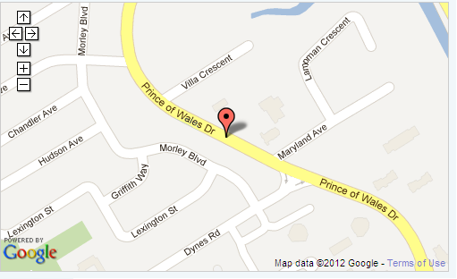
http://www.hellenicottawa.ca/
If you have special needs (food allergies or handicap accessibility)
please contact the banquet director to discuss requirements.

