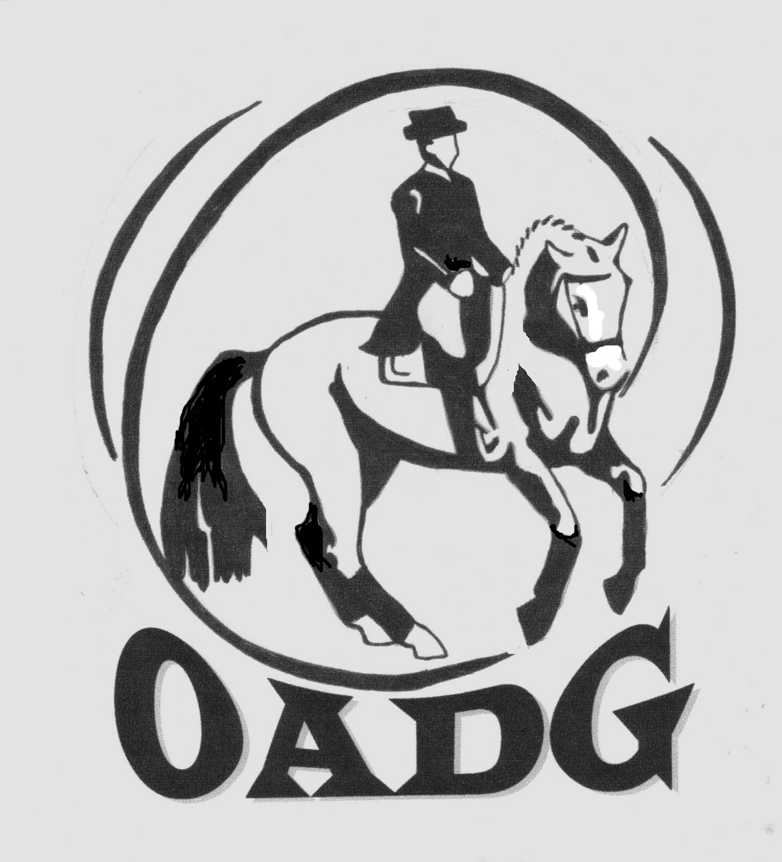
OTTAWA AREA DRESSAGE GROUP

OADG AWARDS BANQUET
Saturday, November 22, 2014

TICKET ORDER FORM

All tickets must be ordered and payment received by one of the OADG Directors by the end of the day on Saturday, November 15, 2014.

All tickets will be available for pick-up at the door only. Tickets will not be mailed.
Tickets will not be available for purchase after Saturday, November 15, 2014.

For more information or if you have special needs (food allergies or handicap accessibility), please contact the Banquet Director to discuss your requirements.

Marie-Christine Boucher (Banquet Director)
613-573-0075 or 819-319-3202 -- banquet@ottawadressage.ca

LAST NAME: __________________________ FIRST NAME: __________________________

ADDRESS: ____________________________________________________________________

CITY:_______________________ PROVINCE:_______________ POSTAL CODE:___________

HOME PHONE: ______________________ BUSINESS PHONE: _________________________

EMAIL ADDRESS: ______________________________________________________________

 | Price per ticket | Number of tickets | Total cost
Adult tickets | $38.00
Children tickets  (10 and under) | $20.00
Total cost | *********** | **********
(Drinks are not included in ticket price. Cash bar is available at the event)

Table reservation name: ___________________________________

(Only ONE member of your party should reserve a table with the form on the reverse, all others only need to register the table name on this form).

Send ticket order form and cheque made payable to O.A.D.G. to:
OADG Banquet
c/o Marie-Christine Boucher
2315 Stoney Lane
Cumberland, ON K4C 1B9

(Or hand-deliver to one of the OADG Directors by November 15, 2014)

OTTAWA AREA DRESSAGE GROUP

OADG AWARDS BANQUET
Saturday, November 22, 2014

TABLE RESERVATION FORM

Note that ONLY ONE person in your party needs to register a table. All other people in your party should indicate on the ticket order form which table they wish to be seated at.

A table reservation does not guarantee tickets. Tickets must be purchased separately in advance. (See ticket order form for purchasing deadline).

There are eight (8) people to each table. Ten (10) can be accommodated by special request, please send an email to: banquet@ottawadressage.ca

Table reservation name #1: (stable/person):
1:
2:
3:
4:
5:
6:
7:
8:

Table reservation name #2: (stable/person):
1:
2:
3:
4:
5:
6:
7:
8:

Send table reservation form to:

OADG Banquet
c/o Marie-Christine Boucher
2315 Stoney Lane
Cumberland, ON K4C 1B9

