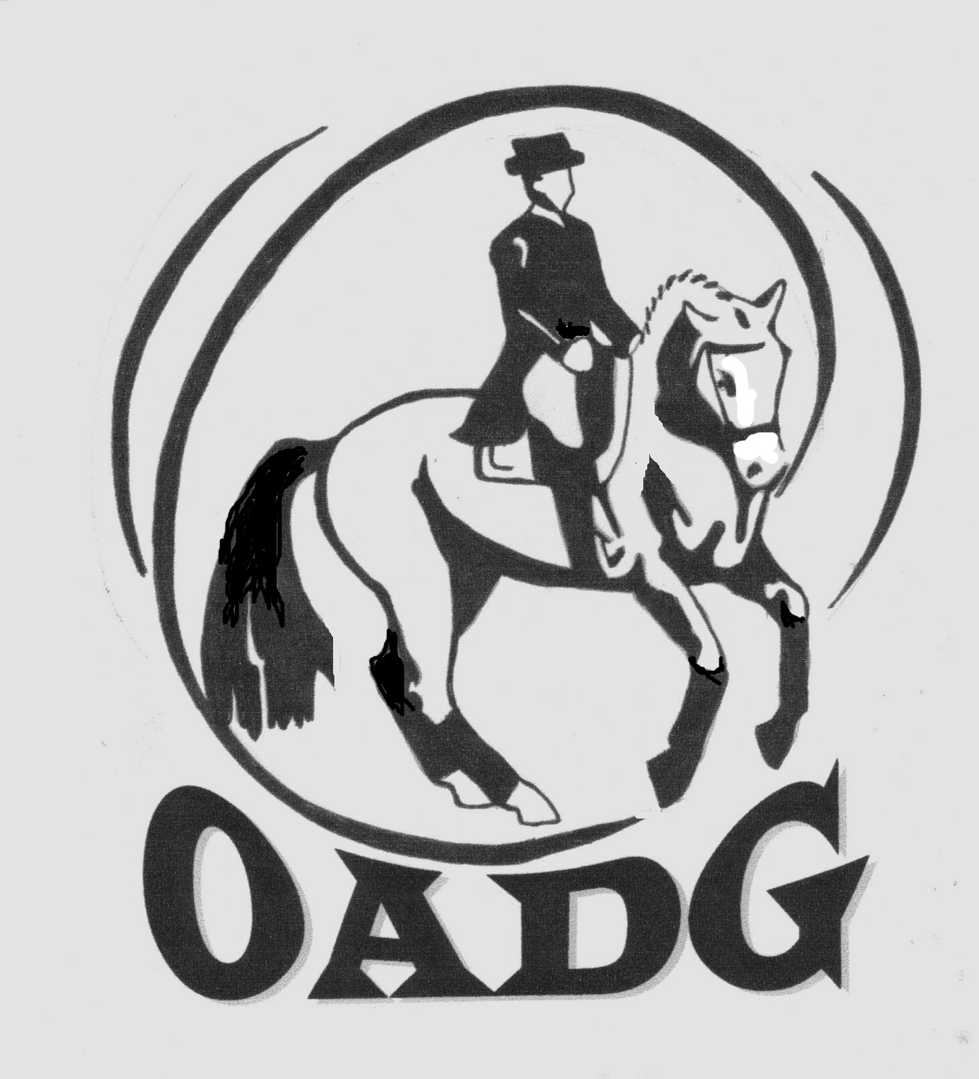
OTTAWA AREA DRESSAGE GROUP

OADG AWARDS BANQUET
Saturday November 17th 2012

TICKET ORDER FORM:
(Drinks are not included in ticket price; Cash Bar is available at the event)

All tickets must be ordered and payment received by one of the OADG Directors by the end of the day Saturday November 10th 2012

All tickets will be available for pick-up at the door only.
No tickets will be mailed

No tickets will be available for purchase after November 10th 2012

If you have special needs (food allergies or handicap accessibility)
please contact the banquet director to discuss your requirements.

For further information contact: Darlene Grant
613-433-5759
banquet@ottawadressage.ca

LAST NAME: __________________________ FIRST NAME: __________________________

ADDRESS: __________________________________________________________________

CITY:_______________________ PROVINCE:__________________ POSTAL CODE:___________

HOME PHONE: ______________________ BUSINESS PHONE: _______________________

EMAIL ADDRESS: ___________________________________________________

 | Price Per Ticket | Number of Tickets | Total Cost
Adult Tickets | $42.00
Children’s Tickets  (10 and under) | $23.00
Total Cost | *********** | **********
(make cheques payable to O.A.D.G.)

Table Reservation Name: ______________________

(only ONE member of your party should reserve a table with the form on the reverse,
all others only need to register the table name on this form.)

Send Ticket Order form and cheque made payable to O.A.D.G. to:
OADG Banquet
c/o Darlene Grant
228 Cobus Rd.
Renfrew, On
K7V 3Z8

(Or hand deliver to one of the OADG Directors by November 10th 2012)
OTTAWA AREA DRESSAGE GROUP

OADG AWARDS BANQUET
Saturday November 17th 2012

TABLE RESERVATION FORM:

Note that ONLY ONE person in your party needs to register a table. All other people in your party should indicate on the ticket order form which table they wish to be seated at. A table reservation does not guarantee tickets!
Tickets must be purchased separately in advance!
(See ticket order form for purchasing deadline!)

There are 8 people to each table. 10 can be accommodated by special request. Please send an email to banquet@ottawadressage.ca.

Table Reservation Name #1: (stable/person):
1:
2:
3:
4:
5:
6:
7:
8:

Table Reservation Name #2: (stable/person):
1:
2:
3:
4:
5:
6:
7:
8:

Send Table Reservation form to:
OADG Banquet
c/o Darlene Grant
228 Cobus Rd.
Renfrew, On
K7V 3Z8

