FOR SALE OR FULL LEASE
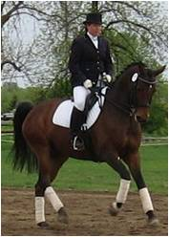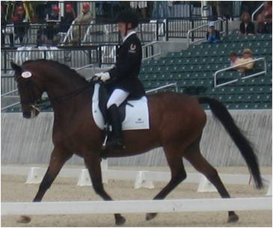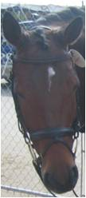

Karajan is a 12 year old Trakehner gelding by Tanzmeister out of Kiba. He has 3 excellent gaits, is schooling at 4th/PSG level and has shown successfully at these levels. He can do up to 2 tempis and half canter pirouettes. Member of the 2009 Ontario FEI Junior Gold Medal Team at the North American Junior Championships. A very fun and talented horse to ride. Would be an ideal horse for an FEI Junior Rider or an experienced adult amateur. He is a very athletic horse and enjoys his work.
Karajan is very quiet and gentle to handle in the barn. He is well behaved with vets and farriers, trailers well and enjoys hacking.
Lease conditional on staying in Ottawa.
Sale Price: $50,000
Contact Sarah Mcilwham for more details.
Tel: (C) 613-850-6239 (H) 613-421-8908
Email: smcilwham@gmail.com

