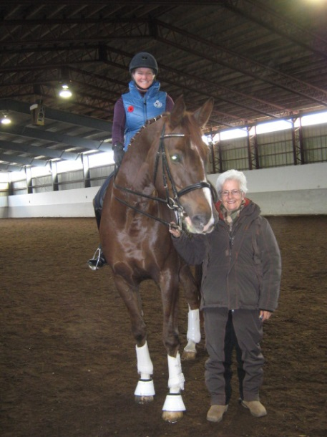

**“Spring Warm Up”**

**Dressage Clinic**

**with**

**Cara Whitham**

**Saturday, April 5, 2014**

**Sunday, April 6, 2014**

**Sunday, November 3**

**Please visit “Events” at** [**www.stonehavendressage.com**](http://www.stonehavendressage.com) **for**

**Rider Registration forms and Auditor Registration forms.**

For information please contact:

Kate Hoffman at [cathrynraehoffman@gmail.com](mailto:cathrynraehoffman@gmail.com) or (613) 314-0560

Cara Whitham is currently the only judge in the world to hold the top official’s license for Dressage (5*) and Eventing (O), from the International Equestrian Federation (FEI). After becoming the first and only Canadian judge to hold her ‘O’ status for Eventing, she was awarded her ‘5*’ status for dressage in 2004. In 2010 Cara was included on the FEI list of approved Dressage Technical Delegates.

Cara’s impressive Dressage officiating includes; CDIO Aachen, CDIs in England, France, Australia, New Zealand, Germany, Portugal, Italy, Uruguay, Mexico, Brazil, the Caribbean, USA and Canada. She has officiated at Canadian and USA World Cup League finals, twice on the panel for the FEI World Young Rider Finals, the 2003 and 2011 Pan Am Games, 2005 European Dressage Championships, 2007 FEI World Cup Final, 2010 World Equestrian Games and most recently Technical Delegate for the 2011 and 2013 NAYR/JC in Kentucky. Equally impressive are her credentials for officiating at 3 Day Eventing venues, including the 1998 and 2002 World Equestrian Games and the 2004 Athens Olympics.

Cara is a certified Level 3 Dressage Coach, an examiner and level 1,2,3 Course Conductor. Over several years, Equine Canada has re-designed the Coaching program, as sanctioned by the Coaching Association of Canada and NCCP. Cara has been appointed, by these organizations, as a High Performance Specialist coach & Master Evaluator for Ontario. She has coached a team member of the NAYRC Gold Medal Event team, as a well as an Individual Bonze Dressage medalist.

Her company Equivents, is based in the Toronto region and organizes CDI-Ws or CDI3* events annually. In addition Cara is the familiar voice doing the technical commentary for CBC and now CTV’s World Equestrian Games and Olympic coverage.