**RIDE YOUR TEST CLINIC**

**This clinic will be offered as a practice and / or for preparation**

**to compete in the Silver Dressage show on Sunday June 05 ,2016.**

**Come and practice your test in the competition ring . You will be judged and receive immediate feedback , then ride the test again .**

**Where : Graystone Equestrian Centre**

**When : June 04 , 2016 10:00 – 3:00**

**Cost per session : $ 50.00 + HST**

**Clinician : Kerstin Blaeske Equine Canada High Performance Coach 1**

**Equine Canada Level 3 Coach Dressage**

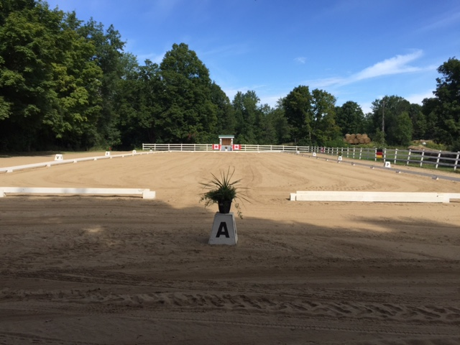

**Registration for clinic**

**Name of Rider ______________________________________________**

**Name of Horse ______________________________________________**

**Test requested**

|  |  |  |  |
| --- | --- | --- | --- |
| **Walk and Trot** | **Test B** | **Test C** |  |
| **Training** | **Test 1** | **Test 2** | **Test 3** |
| **First level** | **Test 1** | **Test 2** |  |
| **Second level** | **Test 1** | **Test 2** |  |
| **Third level** | **Test 1** | **Test 2** |  |
| **Fourth level** | **Test 1** | **Test 2** |  |
| **Other** |  |  |  |
| **Other** |  |  |  |
|  |  |  |  |

**Cost per test $ 50.00 additional test $ 35.00**

|  |  |
| --- | --- |
| **Total for clinic** |  |
| **Stall ( optional $ 50.00 / day )** |  |
| **Add HST** |  |
| **Total fees** |  |

**Please make cheque payable to : Graystone Equestrian Centre**