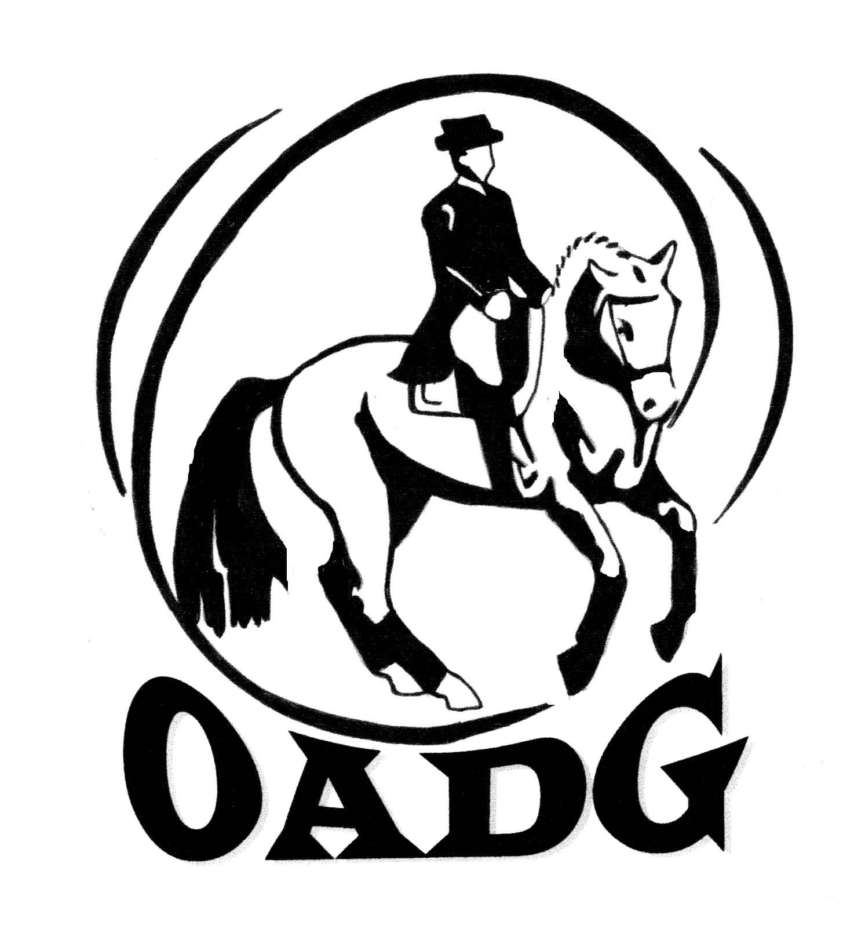
O.A.D.G. Cindy Ishoy Clinic -- Auditor Pre-Registration Form
Location: Oakhurst Farm April 27 and 28, 2013

Location: 8249 Fernbank Rd. Ashton, Ontario - easy access from Hwy 7 and Dwyer Hill Road - go to http://www.oakhurstfarm.com for detailed directions to the farm

Oakhurst Farm has bleachers to accommodate auditors, but you may bring chairs (and cushions). There is ample parking on the property. Clinic hours are 8:00am to 5:00pm with approximately 1 ½ hours for lunch. Please check http://ottawadressage.ca for the schedule the week before the clinic.

Food: Food and refreshments will be available for purchase on site – a fundraiser for the Ashton First Field Pony Club. You may brown bag it or find an alternative in Stittsville.

Please note: In order to pre-register, this form must be received by the Clinic Secretary no later than April 21, 2013. Please register well in advance of this date to ensure your spot. Cheques must be dated no later than April 21, 2013, preferably earlier.

Auditing hours may be accredited for 6 hours of coaching certification. Forms will be available at the Clinic.

Auditor Name: |  | Phone:
Address: |  | Cell Phone:
Email:

I wish to register for the following:

OADG Members Non-Members Total

Sunday $25 $35 $_______

Saturday $25 $35 $_______

Total Fees Enclosed: $_______

After April 21, 2013, you must register on-site, cash only. The walk-in registration fee per day is $30 for OADG members and $40 for Non-members.

I heard of the clinic through OADG; Facebook; Word of mouth; other: ___________

Please send completed pre-registration form along with payment to:
Peggy McQuaid Box 425, Stittsville, ON., K2S 1A6

Cheque payable to O.A.D.G.

Questions: can be directed to the Clinic Secretary, Peggy McQuaid at 613-831-2692 or education@ottawadressage.ca.

