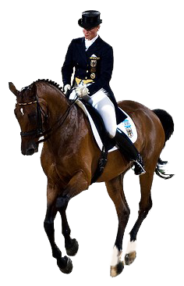

IronWood Farms Proudly Presents:

Rider Schedule

Jacquie has requested and will be wearing a microphone so she is able to include auditors in her teaching process. It is our goal for this clinic to be representative of a cross-section of riders and horses of all levels and ages. We will strive to ensure that auditors at all skill levels have the opportunity to observe and learn from riders that they can identify with.

**Friday Oct 23rd 2015**  
1pm Verena Gharibzadeh ( Third Level)  
1:45pm Kristina Bramwell-Panchuk (Second Level)  
2:30pm Beth Mansfield  
3:15pm Sorina Ostiguy / Caroline Hollingworth  (First level)

4-5pm SUPPER

5pm Deanna Russell (Second level)  
5:45pm Catherine Demers (Training level)  
6:30pm Pam Overton  (First level)  
7:15pm Allie Young (FEI Juniors)  
  
**Saturday Oct 24th 2015**  
9am Kelsey Baker (FEI 6 yr olds)  
9:45am Christina Conway  (PSG)  
10:30am McKenna Jelly / Paul Oster (FEI childrens)  
11:15am Allison Youngdale (FEI juniors)

12-1pm LUNCH

1pm Debbie Milling (Training Level)  
1:45pm Courtney Cavanagh (Training level)  
2:30pm Sarah Catt (Second level)  
3:15pm Mandy Spear (Third level)

We look forward to seeing you there!