**TOM DVORAK CLINIC**

April 26-27, 2014

Hosted by: Blueprint Farm

Location: Dewmont Farm

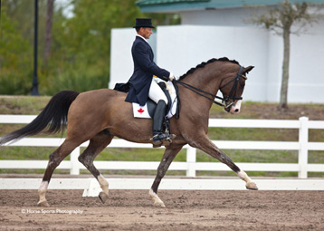

|  |  |  |  |
| --- | --- | --- | --- |
| **Saturday, April 26** | | **Sunday, April 27** | |
|  | | | |
| 09:00 | Sue Ziereisen – Denali  *2nd level* | 08:00 | Sue Ziereisen - Denali  *2nd level* |
| 09:45 | Ron King – Drago  *PSG/Inter1* | 08:45 | Ron King – Drago  *PSG/Inter1* |
| 10:30 | Ashley Phipps – Diandra  *2nd level* | 09:30 | Ashley Phipps – Diandra  *2nd level* |
| 11:15 | Ron King – Rex  *Inter2/Grand Prix* | 10:15 | Ron King – Rex  *Inter2/Grand Prix* |
| 12:00 | Fran Nicol – Cinnamon *1st Level* | 11:00 | Lea Mitchell – Kairos  *1st Level* |
| 12:45 | Lunch | 11:45 | Lunch |
| 13:30 | Cathy Knight – Saba  *Training Level* | 12:15 | Penny Greenwood – Sweetheart *3rd Level* |
| 14:15 | Kim Doucette-Bell – Allegra *Training Level* | 13:00 | Jen Rafaletos – Risci  *2nd/3rd Level* |
| 15:00 | Penny Greenwood – Sweetheart *3rd Level* | 13:45 | Fran Nicol – Cinnamon *1st Level* |
| 15:45 | Lea Mitchell –Kairos  *1st Level* | 14:30 | Kim Klotins – Sultan of Swing  *4th Level* |