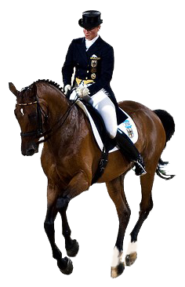

IronWood Farms Proudly Presents:

Auditor Registration Form

Please join us at IronWood Farms for an inclusive auditor experience with Jacquie Brooks!

Jacquie has requested and will be wearing a microphone so she is able to include auditors in her teaching process. It is our goal for this clinic to be representative of a cross-section of riders and horses of all levels and ages. We will strive to ensure that auditors at all skill levels have the opportunity to observe and learn from riders that they can identify with.

AUDITOR INFORMATION

Name: __________________________________________________________________________ Telephone Number: __________________________

Address: ________________________________________________________________________________________________________________________

Email Address: _________________________________________________________________________________________________________________

AUDITOR FEES

|  |
| --- |
| **PAST EARLY BIRD DEADLINE UPDATE**  **Form must be** received **by THURSDAY OCTOBER 22ND, 2015 to pay by cheque or EMT** |
| For those of you registering past our early bird deadline of October 9th, 2015 there is **ONE AUDITING PRICE** available.  **Join us Friday October 23rd from 1pm-8pm and/or* Saturday October 24th from 9am-4pm for $60.00**  *$60.00 auditing fee will not be split into a per day cost – one fee applies regardless of attendance one or both days |

WALK INS

Walk ins are welcome if space is available and **only $60.00 cash** will be accepted at the door.

SEATING

To guarantee seating for yourself, please bring a portable chair of some kind. We will have limited bleacher seating available. We do intend to hold the clinic outside so please remember to dress accordingly for the late October season. In the case of inclement weather we will move the clinic indoors where auditors will be seated in both our viewing area as well as a specific section of our arena itself.

FOOD AND BEVERAGES

Food and beverages will be available for purchase on site.

UPDATING RECORDS FOR COACHES AND INSTRUCTORS

Coaches and instructors will be granted up to six updating points for the duration of the clinic – three points per eight hour auditing day. Please check the box below if you would like us to provide a copy of the updating record for you. Feel free to print your own from our website as well!

I would like a copy of the updating record available for me on site.



PARKING

Plenty of parking will be available in designated areas. Please follow directions once on property to avoid driving in restricted zones.

DOGS

Out of respect for our equine friends we request that you leave your canine companions at home. Thank you.

REGISTRATION

Please send this registration together with all fees to: Scan and email registration form along with an

**OR**

8071 County Road 22 **IronWood Farms**

Spencerville, Ontario Email Money Transfer to:

K0E 1X0 **erinljosey@gmail.com**

**Please make cheques payable to: “Erin Josey”**

Please no post-dated cheques.

*There will be no auditors’ refunds under any circumstances.*