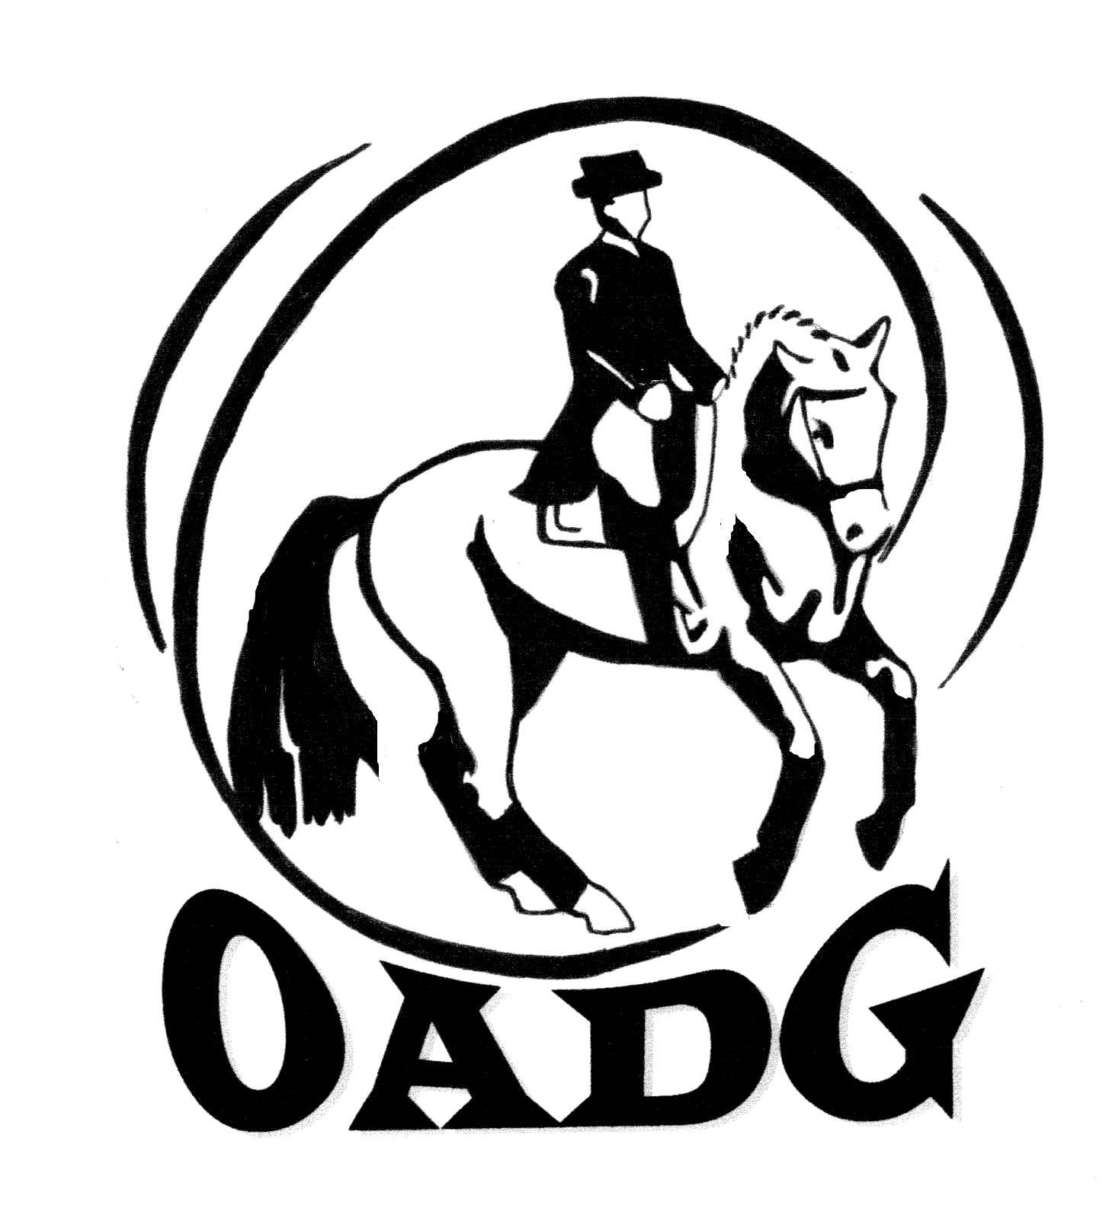
OTTAWA AREA DRESSAGE GROUP of CADORA
2013 MEMBERSHIP APPLICATION

OADG is a local group affiliated with both CADORA and Dressage Canada. The OADG is a not-for-profit organization whose purpose is to foster the sport of Dressage by encouraging participation in Competitions, Demonstrations, Lectures and other activities which increase knowledge and understanding of good horsemanship. Memberships run from January 1st to December 31st. Senior memberships must be renewed with the OADG, CADORA Ontario and CADORA National no later than May 31st to retain voting privileges and ensure eligibility for all applicable awards.

You MUST join no later than May 31st in order to qualify for OADG awards.
Both the rider and owner of the horse (if different) must be members of the OADG by May 31st. Owners must have at least an OADG local membership. (Scores up to and including May 31st are also valid for year-end awards as long as your membership is received by May 31st.)

MEMBERSHIP INFORMATION: NEW__ RENEWAL__ CADORA#___________ OEF#____________ EC#____________

LAST NAME_______________________________ FIRST NAME_________________________

ADDRESS_______________________________________________________________________

CITY__________________________ PROVINCE______________ POSTAL CODE_____________

HOME PHONE__________________________ BUSINESS PHONE________________________

Newsletter Delivery by Email only (or mark no newsletter if you do not wish to have one)
– make sure your email address is legible and correct!

EMAIL (Please print clearly) _______________________________________________________________

DRESSAGE OFFICIAL: COACH____ JUDGE____ STEWARD____ LEVEL___________________

COMPETITION CATEGORY: JUNIOR____ ADULT AMATEUR____ OPEN____
DATE OF BIRTH FOR JUNIOR:_______________ JR PARENT/GUARDIAN NAME:_________________________

COMPETITION LEVEL: SCHOOLING___ BRONZE___ SILVER___ GOLD___ PLATINUM/CDI___

Membership Fees:
(Only a full CADORA National membership includes one Omnibus, CADORA National Membership Card and CADORA INC newsletters.)

MEMBERSHIP TYPES – Select One CHOOSE ONE ONLY
OADG LOCAL ONLY SR $30.00___ JR $20.00___
CADORA ONTARIO SR $40.00___ JR $30.00___ (Includes local membership)
CADORA NATIONAL SR $70.00___ JR $50.00___ (Includes local, and Ontario membership)
CADORA QUEBEC NATIONAL SR $60.00___ JR $40.00___ (Only for Quebec residents not showing Silver)

Membership Type Selected:______________________ FEE: $_______

Supplies: You can only order from these supplies if you have joined CADORA NATIONAL
Additional Omnibus ($20.00 each) $______ BaseBall Cap RED ($20.00 each) $______
Omnibus Rain Cover ($2.00 each) $______ BaseBall Cap BLACK ($20.00 each) $______
Additional Lapel Pin ($5.00 each) $______ Additional Test Planner ($5.00 each) $______
Policy & Procedures Manual ($25.00 each) $______

TOTAL REMITTED FOR MEMBERSHIPS, SUPPLIES (Supplies ONLY For CADORA National) $________

Make cheque payable To: Ottawa Area Dressage Group of CADORA (or OADG) (NO POST DATED CHEQUES PLEASE)

Membership is valid as of the date the completed form and fee are received by the OADG membership director.
Fee must accompany completed application form

Mail to: Michelle Crocker-Wells Phone: 613-835-2947
3952 Rockdale Rd. Email: membership@ottawadressage.ca
Navan, On OADG WebSite: www.ottawadressage.ca
K4B 1H9

A membership in any level of the OADG, CADORA Ontario or CADORA National is not required for a rider or horse to compete in dressage competitions, but is required to be eligible for any year-end awards or competition grants sponsored by the OADG, CADORA Ontario or CADORA National.
OTTAWA AREA DRESSAGE GROUP of CADORA
2013 MEMBERSHIP INFORMATION

Privacy Policy: The OADG will not share your personal information with third parties unless required for business directly related to the OADG (such as forwarding member information to CADORA). If we judge an issue or information item to be of interest to our members, we will forward that information to you directly by email from within the OADG Director group.

The OADG membership packages are divided by levels identifying total fees required to join either: OADG (local group), CADORA Ontario (COAI), or CADORA National. There is also a level for those residing in Quebec, not having a provincial affiliate and thus not required to join CADORA Ontario. Each member can choose the membership package that fits their particular preferences.

A membership in any level of OADG, CADORA Ontario or CADORA National is not required for a rider or horse to compete in dressage competitions. However; it is necessary for both the rider and at least one owner of the horse (if different) to be members in order to be eligible for any year-end awards or competition grants sponsored by the OADG, CADORA Ontario or CADORA National. Memberships are required to be in by May 31st to be eligible for OADG, CADORA Ont or CADORA Inc awards.

MEMBERSHIP PACKAGES:
LOCAL: OADG Local membership ONLY (Senior/Junior)
ONTARIO: OADG Local membership and CADORA ONTARIO membership (Senior/Junior)
NATIONAL: OADG Local membership and CADORA Ontario membership and CADORA National membership (Senior/Junior)
QUEBEC NATIONAL: OADG Local membership and CADORA National membership (Senior/Junior)

The following is a summary of what each membership package includes:

LOCAL – OADG  Ottawa Area Dressage Group of CADORA | - Eligible for local OADG year-end awards for FEI, Gold, Silver, Bronze, Schooling Permit competitions. Rider and at least one owner of the horse must be members by May 31st to be eligible for year-end awards. (Except for the overall PeeWee Award)  - OADG Local group newsletter  - Eligible to ride in OADG sponsored clinics  - Eligible to vote in local OADG group elections at AGM, and stand for director  - Affiliated with Dressage Canada
ONTARIO - COAI  Cadora Ontario Association Inc. | Local OADG Package plus:  - Eligible for COAI, Silver, Bronze awards  - CADORA Ontario newsletters  - Vote in COAI elections and stand for director  - Access to CADORA Ontario scholarship programs
NATIONAL -  Cadora National Inc. | Ontario package plus:  - One CADORA Omnibus  - CADORA National quarterly newsletters  - Purchase CADORA National supplies (Omnibus, lapel pin, rain covers)  - Eligible for CADORA National FEI, Gold awards  - Vote in CADORA National elections at AGM and stand for Director (if renewed by May 31st)

Quebec residents competing on the Ontario Silver circuit must join CADORA Ontario to be eligible for year-end CADORA Ontario Silver awards. Quebec residents do have the option of not joining CADORA Ontario if they are not competing on the Ontario Silver Circuit.

Supplies: Supplies are for CADORA NATIONAL members ONLY

Note: All OADG members participating in OADG shows and clinics must be members of the OEF for insurance purposes. It is recommended that clinic organizers ask for participant OEF number.

Please do not send the OADG membership director Ontario Equestrian Federation (OEF) memberships or Equine Canada (EC) memberships or Dressage Canada (DC) memberships. These should be sent directly to the respective OEF or EC membership offices.

