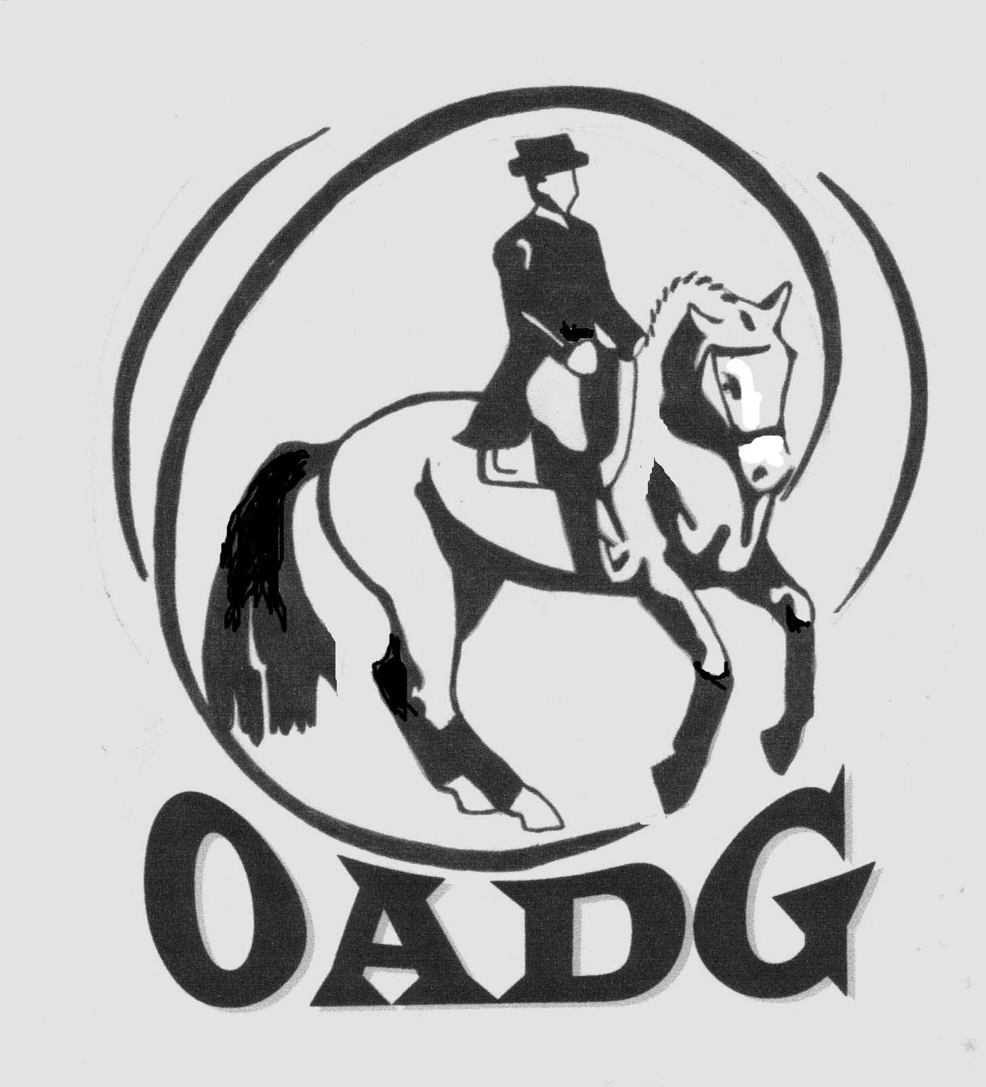
OTTAWA AREA DRESSAGE GROUP (OADG)
Do you have an interest in dressage, participate in dressage shows,
want to know what is going on in the local dressage community?
Then come join us – your local area dressage group!
Ottawa Area Dressage Group
The OADG is a chapter of CADORA Inc. and a Dressage Canada riding club.
We offer:
Informative clinics, newsletters, annual awards banquet with over 130 award levels, and more…
Silver Dressage Championship Eastern Division – September 14th, 2014
2014 Local Senior membership: $30.00 2014 Local Junior membership: $20.00
Check us out at www.ottawadressage.ca or contact our membership director:
Cathy Gordon 613-257-5145 membership@ottawadressage.ca
Local Area Dressage Shows
(dates are subject to change; check our website for the most up-to-date listings)
OEF Permit Schooling
May 4 Spiritwood Joanna MacDonald 613-489-3262 http://spiritwoodfarm.ncf.ca
May 11 Heroncrest Diana Bayer 613-283-8084 www.heroncrestables.com
May 18 Starlit Lise Clark 613-838-3036 www.starlitfarm.net
May 31 Oakhurst Mark Nelson 613-227-9784 http://oakhurstfarm.com
June 21 Numech Caroline Peck 613-248-0018 www.facebook.com/primaryclassic
June 29 Spiritwood Joanna MacDonald 613-489-3262 http://spiritwoodfarm.ncf.ca
July 20 Spiritwood Joanna MacDonald 613-489-3262 http://spiritwoodfarm.ncf.ca
July 20 Centaur Shirley Guertin 613-835-2237 www.centaurridingschool.com
July 27 Heroncrest Diana Bayer 613-283-8084 www.heroncrestables.com
Aug 16 Oakhurst Mark Nelson 613-227-9784 http://oakhurstfarm.com
Aug 24 Skyline Farm Nonie Smart 613-832-8071 http://www.skylinefarm.ca
Aug 31 Spiritwood Joanna MacDonald 613-489-3262 http://spiritwoodfarm.ncf.ca
Sept 21 PrestonRosedale Carolyn Rathwell 613-264-5411 http://www.prestonrosedale.com
Oct 5 Centaur Shirley Guertin 613-835-2237 www.centaurridingschool.com
Silver
May 25 Spiritwood Joanna MacDonald 613-489-3262 http://spiritwoodfarm.ncf.ca
June 14 Rainbow Ridge Curtis/Maltby 613-821-2939 http://rainbowridgeranch.ca/
June 22 Dewmont Heather Snipper 613-253-1227 www.dewmontfarms.ca
July 5 Numech Melissa Thompson 613-831-5223 http://numechequestriancentre.ca/
Aug 3 Centaur Shirley Guertin 613-835-2237 www.centaurridingschool.com
Aug 10 Spiritwood Joanna MacDonald 613-489-3262 http://spiritwoodfarm.ncf.ca
Aug 23 Numech Melissa Thompson 613-831-5223 http://numechequestriancentre.ca/
Sept 14 (Championship)@Oakhurst Mark Nelson 613-227-9784 http://oakhurstfarm.com
Gold
May 18 Centaur Shirley Guertin 613-835-2237 www.centaurridingschool.com
May 30 Ottawa Dressage Festival (NNEP) 613-733-7505 www.nationalcapitaldressage.ca
to June 1
June 14-15 Rainbow Ridge Curtis/Maltby 613-821-2939 http://rainbowridgeranch.ca/
July 12-13 Rainbow Ridge Curtis/Maltby 613-821-2939 http://rainbowridgeranch.ca/
Also check the OADG website for non-permit schooling shows in the area,
and other SILVER/GOLD/BRONZE shows outside of the Ottawa area.

