 **CENTAUR SUMMER**

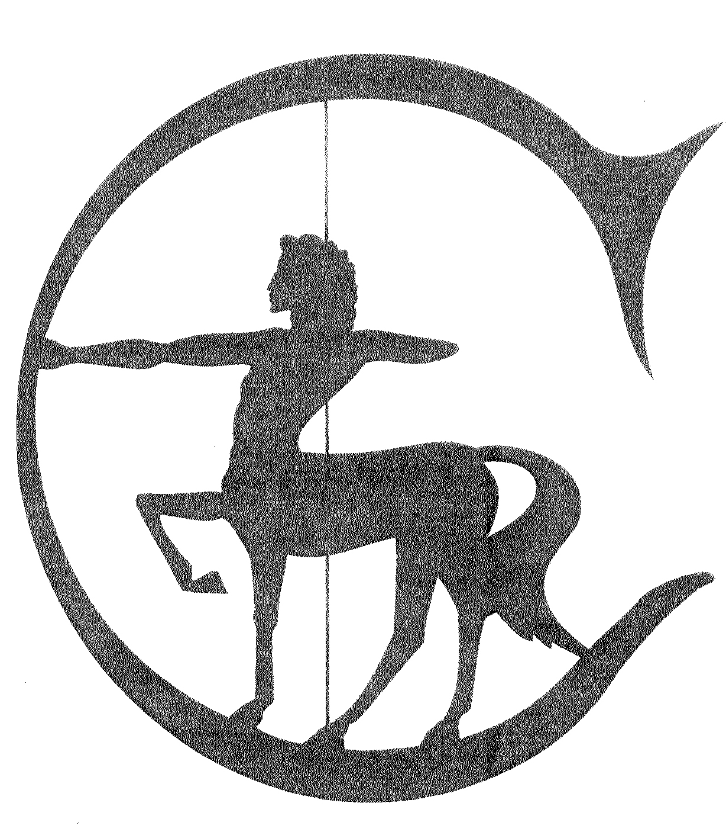

**GOLD & SILVER**

**DRESSAGE SHOW**

**August 6, 2017**

*The Centaur Summer Dressage Show is sanctioned as both a Gold and Silver member of Equestrian Canada,*

*308 Legget Drive, Suite 100, Ottawa, Ontario K2K 1Y6 and is governed by the Rules of EC.*

**OFFICIALS**

|  |  |
| --- | --- |
| JUDGES | Lorraine MacDonald, Terra Cotta, Ontario  Marlene Davis, Blainville, QC |
| STEWARD | Christine Hickman, Dunrobin, Ontario |
| SECRETARY | Shirley Guertin, (613) 835-2237, info@centaurridingschool.com |

**CLOSING DATE**

* July 25, or when full - Entries and all fees must be received by this date.
* Entries are accepted on a first come basis. They will be closed as soon as the day is full.

**GOLD SHOW - LEVELS, TESTS & FEES**

|  |  |  |  |  |  |  |  |  |  |  |  |
| --- | --- | --- | --- | --- | --- | --- | --- | --- | --- | --- | --- |
| **#** | | | **Level** | | | **Test** | | **Ring Size** | | | **FEES**  Training (20x40 ring): $40 / class  First & Second: $50/ class  Third & Fourth: $60 /class  FEI CLASSES: $70 / class |
| 1 | | | Training Level | | | 1 | | 20x40 | | |
| 2 | | | Training Level | | | 2 | | 20x40 | | |
| 3 | | | Training Level | | | TOC | | 20x40 | | |
| 4 | | | First Level | | | 1 | | 20x60 | | |
| 5 | | | First Level | | | 2 | | 20x60 | | |
| 6 | | | First Level | | | TOC | | 20x60 | | |
| 7 | | | Second Level | | | 2 | | 20x60 | | |
| 8 | | | Second Level | | | TOC | | 20x60 | | |
| 9 | | | Third Level | | | 2 | | 20x60 | | |
| 10 | | | Third Level | | | TOC | | 20x60 | | |
| 11 | | | Fourth Level | | | 2 | | 20x60 | | |
| 12 | | | Fourth Level | | | TOC | | 20x60 | | |
| 13 | | | FEI Pony, Children’s, Junior, YR | | | TOC | | 20x60 | | |
| 14 | | | FEI Pony, Children’s, Junior, YR | | | TOC | | 20x60 | | |
| 15 | | | FEI PSG to GP | | | TOC | | 20x60 | | |
| 16 | | | FEI PSG to GP | | | TOC | | 20x60 | | |
| 17 | | | FEI Young Horse 4,5,6 yr old | | | TOC | | 20x60 | | |
| 18 | | | FEI Young Horse 4,5,6 yr old | | | TOC | | 20x60 | | |
| 19 | | FEI Para | | | | TOC | | 20x40  or 20x60 | | |  |
| 20 | | FEI Para | | | | TOC | | 20x40  or 20x60 | | |  |
|  | **MISCELLANEOUS CLASSES**  *(non-rated for EC awards)* | | | | | | | |  |  |  |
| 21 | | | | Walk/Trot - Open | A | | 20x40 | | | | Walk/Trot: $40 / class |
| 22 | | | | Walk/Trot - Open | B | | 20x40 | | | |  |

**SILVER SHOW - LEVELS, TESTS & FEES**

|  |  |  |  |  |  |  |  |  |  |  |  |
| --- | --- | --- | --- | --- | --- | --- | --- | --- | --- | --- | --- |
| **#** | | | **Level** | | | **Test** | | **Ring Size** | | | **FEES**  Training (20x40 ring): $40 / class  First & Second: $50/ class  Third & Fourth: $60 /class  FEI CLASSES: $70 / class |
| 23 | | | Training Level | | | 1 | | 20x40 | | |
| 24 | | | Training Level | | | 2 | | 20x40 | | |
| 25 | | | Training Level | | | TOC | | 20x40 | | |
| 26 | | | First Level | | | 1 | | 20x60 | | |
| 27 | | | First Level | | | 2 | | 20x60 | | |
| 28 | | | First Level | | | TOC | | 20x60 | | |
| 29 | | | Second Level | | | 2 | | 20x60 | | |
| 30 | | | Second Level | | | TOC | | 20x60 | | |
| 31 | | | Third Level | | | 2 | | 20x60 | | |
| 32 | | | Third Level | | | TOC | | 20x60 | | |
| 33 | | | Fourth Level | | | 2 | | 20x60 | | |
| 34 | | | Fourth Level | | | TOC | | 20x60 | | |
| 35 | | | FEI Pony, Children’s, JR, YR. PSG, Int 1 | | | TOC | | 20x60 | | |
| 36 | | | FEI Pony, Children’s, JR, YR. PSG, Int 1 | | | TOC | | 20x60 | | |
| 37 | | FEI Para | | | | TOC | | 20x40  or 20x60 | | |  |
| 38 | | FEI Para | | | | TOC | | 20x40  or 20x60 | | |  |
|  | **MISCELLANEOUS CLASSES**  *(non-rated for EC awards)* | | | | | | | |  |  |  |
| 39 | | | | Walk/Trot - Open | A | | 20x40 | | | | Walk/Trot: $40 / class |
| 40 | | | | Walk/Trot - Open | B | | 20x40 | | | |  |

**EQUESTRIAN CANADA’S STATEMENT OF PRINCIPLE**

Equine Canada (EC), the national equestrian federation of Canada, supports adherence to the humane treatment of horses in all activities under its jurisdiction.

EC is committed to:

• upholding the welfare of all horses, regardless of value, as a primary consideration in all activities;

• requiring that horses be treated with kindness, respect and compassion, and that they never be subjected to mistreatment;

• ensuring that owners, trainers and exhibitors, or their agents, use responsible care in the handling, treatment and transportation of their own horses as well as horses placed in their care for any purpose;

• providing for the continuous well-being of horses by encouraging routine inspection and consultation with health care professionals and competition officials to achieve the highest possible standards of nutrition, health, comfort and safety as a matter of standard operating procedure;

• providing current information on Code of Practice for the Care and Handling of Equines and other equine health and welfare initiatives;

• continuing to support scientific studies on equine health and welfare;

• requiring owners, trainers and exhibitors to know and follow their sanctioning organization’s rules, and to work within industry regulations in all equestrian competition; and

• Actively promoting the development of and adherence to competition rules and regulations that protect the welfare of the horse.

The Standard by which conduct or treatment will be measured is that which a person, informed and experienced in generally accepted equine training and exhibition procedures, would determine to be neither cruel, abusive, nor inhumane.

***There will be refreshments available on show grounds provided***

***this year by* Colin & Nicole.**

***They will be present early in the morning for that***

***wake-up coffee!!***

**PRIZES**

* RIBBONS are sponsored by **Cameron N. Uloth Farrier Service**
* Junior &/or Adult Amateur ribbons will be awarded providing there are three or more in the class. Less than three in a category/class will be entered in the Open class of that division.
* Championship Ribbons are sponsored by **Henry Equestrian Plan. Category Show Champions will be determined by two highest test scores. High score prizes will be given out.**
* Sponsors are[**The OADG**](http://www.ottawadressage.ca)**, Horse Sport, Greenhawk, HEP & Centaur Breeding Farm**

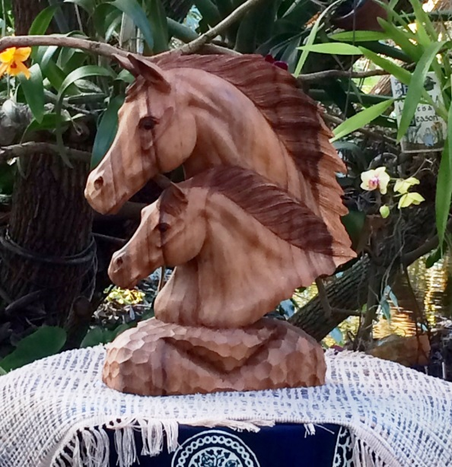

***Thank you to***

***Claire & John Guertin***

***for the beautiful horse sculpture.***

***This***

***hand-carved***

***teak sculpture***

***will be given to the***

***Top Rider of all CRS 2017 shows****.*

**CENTAUR’S YEAR-END AWARDS**

|  |  |
| --- | --- |
| **THE CENTAUR CUP**  **CHALLENGE TROPHY** | This beautiful gold cup donated by [**Centaur** **Riding School**](http://www.centaurridingschool.com) is awarded to the TOP RIDER of all the current year shows held at Centaur. |
| **THE F.X. POTTER**  **EQUITATION TROPHY** | This silver cup, donated in 1976 by **Mr. F.X. Potter and family**, is awarded to Centaur's top equitation student of the current year. All shows count. |
| **THE TGIF/OESS/ESD SERIES AWARDS** | Various awards and trophies will be given for these different series. Please see the individual prize lists for details. |

# OTHER YEAR-END AWARDS

1. The **Centaur Gold & Silver Shows** (May 14 & August 6) count for CADORA, OADG awards and EQUESTRIAN CANADA awards. For full details of EC awards, please look on their website.

**THE CENTAUR POINT SYSTEM**

1st place = 6 pts; 2nd = 4 pts; 3rd = 3 pts; 4th = 2 pts; 5th 1 pt.

Show Coefficients: GOLD = 3; SILVER= 2; OESS/ESD = 1; TGIF= 1.

TOTAL = Placing points x # of entries in class x Show coefficient

## HOW TO GET TO CENTAUR



**STABLING**

a) Cost is $55.00 per box stall and $45.00 per standing stall per show day, or part of a day. (Show day = 6:30 a.m. to 1 hour after show end.) Add $20 per stall if overnight. (Overnight = from 5:00 pm on. Earlier arrivals than 5:00 pm = a full day. Please indicate time of arrival & departure.

b) Stalls will be assigned in following order: 1) first choice to any horse arriving the day before; 2) second choice will be in the order received/paid

c) Initial bedding of straw is included. If you do not want straw bedding let us know 48 hours prior start of show, and the stall will be left bare. You will need to bring your own bedding.

d) Fees must be paid in advance to reserve space. Stalls are limited.  **Send stabling fee on a separate cheque**. If a stall is not available, cheque will be returned to competitor. If stabling fee has been added to entry fee cheque, refunds will be as a credit note only.

e) Stall sharing is not allowed and stall lessee will be billed for any other horses occupying their space during the competition. Stalls will be reserved only after all conditions are met.

f) SCRATCHES: Half of the stall fee will be credited if scratched minimum of 48 hours before start time of competition.

g*)* FEE REFUND: $10 of the stall fee will be returned to competitor at the end of day if stall and area is left clean (mucking out not necessary). (Instructions will be emailed out)

h) TACK STALL is available for $45. Same rules as above apply. Only 3 tack stalls available.

**RULES & REGULATIONS**

1. **COMPETITION MANAGER** is Shirley Guertin.
2. **SEND** entries to Centaur Riding School, 3845 Frank Kenny Road, Navan, Ont., K4B 0C6.
   * + Do not send entries by courier. Priority Post (no signature required) is acceptable.
     + If hand-delivering, please place in mailbox at the head of private laneway. Mailbox is labeled “Show Entries”. (mailbox looks like a red barn)
     + Faxed entries are accepted WITH an email money transfer.
     + For email transfers, use this address: [info@centaurridingschool.com](mailto:info@centaurridingschool.com). Security word centaur.
3. **CHEQUES** must be made payable to Shirley Guertin. No post-dated cheques. A FEE of $30.00 will be charged for cheques that are returned from the bank for any reason.
4. **COGGINS TEST**: a copy of a current year negative Coggins test must accompany entries.
5. **CLOSING DATE:** July 25, or when full. Entries and all fees MUST BE RECEIVED by closing date. Entries are accepted on a first come basis. They will be closed as soon as the day is full.
6. **ADMINISTRATION FEE**: A $40.00 administration fee per entry will be charged. Of this fee $10.00 will be refunded to the exhibitor if: 1) all fees have been paid; 2) the entry is received by the required date; 3) the entry form is completely filled out with absolutely no missing information, and 4) everything is together in one envelope.. Refunds must be picked up. They will not be mailed out.
7. **PHONE/ LATE ENTRIES** may be accepted, provided riding times have not been set up. An additional fee of $25 will be charged. For such entries, be prepared to pay via an email money transfer. Without payment, the entry will not be accepted.
   1. **SWAPPING HORSE AND/OR RIDER** into already entered classes will be accepted up to 24 hours prior start of show with a $30 additional fee. Horse and/or Rider must be up to date on all paperwork.
   2. **SCRATCHES**: For entries scratched before the closing date, administration fee will be retained and the balance along with all other fees will be returned to exhibitor. Entries scratched more than 5 days before the start of the show will forfeit administration fee and will have 50% of entry fees credited to a later show; entries scratched more than 48 hours before the start of the show will forfeit administration fee and will have 25% of entry fees credited to a later show. Credits allowed provided a vet or medical certificate is in the hands of the show secretary before the end of the show. All other withdrawals of entries are non-refundable. "No-shows" will forfeit all refunds including administration fee. All cancellations must be made in writing.
   3. **DECISIONS:** Every class offered herein is covered by the Rules and Specifications of the current EC Rule Book and will be held and judged in accordance with said rule book. All questions not covered by these rules shall be decided by the Competition Manager, her decision to be final. The Competition Manager further reserves the right to cancel, combine, change any class and to limit entries.
   4. **TOC –** Test of choice. Please indicate on your entry form the test you wish to ride. TOC divisions are considered to be Open category.
   5. **RING SIZE –** if fewer entries, the Training Level tests may be ridden in the 20x60 ring
   6. **START TIMES** will be posted at [www.CentaurRidingSchool.com](http://www.CentaurRidingSchool.com) and/ or [www.FoxVillage.com](http://www.FoxVillage.com) by the Thursday prior show. Please do not call for riding times. Classes will not necessarily be run in the sequence on the prize list.
   7. **HORSE RECORDINGS -** entries are required to hold an EC Horse Recording and have paid the annual activation fee to compete. Do not send photocopy of horse recording with entries, information will be verified directly with EC. Please note that FEI Para tests do not require that the horse have a horse recording.
   8. **DRUG TESTING**: Any horse entered may, while on the show grounds and on the recommendation of the chairman of the provincial Equine Medication Control Committee or the chairman’s appointee, be selected for equine medication control testing.
   9. **EC, PROVINCIAL & DC MEMBERSHIPS**: Owners & riders at Gold Shows must have an EC Gold Level Sport license as well as be a member in their provincial organization. Owners & riders at Silver Shows must have an EC Silver Level Sport license as well as be a member in their provincial organization. Riders must also be members of Dressage Canada. Photocopies of above are not necessary, as membership status will be verified directly with EC (help save trees!).
   10. **EC DRESSAGE LEVY FEE** – “All EC sanctioned Bronze, Silver, Gold and Platinum Dressage competitions collect and remit $10 per horse entered in the competition to Equestrian Canada. Revenue generated from the Levy is used to support talent identification, personal development and the high performance teams representing Canada at major games”. For the 2017 program, go to <https://www.equestrian.ca/sport/dressage/programs>. Competitors entered in PARA classes are exempt from this fee. PARA riders entering the regular EC or FEI classes are required to pay the DC Levy.
   11. **COMMUNICATION** will be done through email only. Please ensure your correct address is added to the entry form, or you may be left out of the loop!
   12. **PERSON RESPONSIBLE** The Person Responsible (PR) for a horse must be an adult who has, or shares responsibility for the care, training, custody, and /*performance of the horse and who has official responsibility for that horse under EC Rules. The PR is liable under the penalty provisions of the applicable EC Rules for any rule violations.

Every entry form for an EC sanctioned competition must identify the PR and be signed by the PR. The Person Responsible is ultimately responsible for the condition, fitness and management of the horse and is alone responsible for any act performed by himself/herself or by any other person with authorized access to the horse in the stables, elsewhere on the grounds, or while the horse is being ridden, driven or exercised.

A: For adult entries into EC sanctioned competitions the PR shall be either the trainer, the owner of the horse of the competitor who rides or drives the horse during the EC sanctioned competition.

B: For Junior entries into EC sanctioned competitions the Junior competitor cannot be the PR. For Junior entries the PR may be either the trainer, the owner of the horse, or a parent/guardian of the Junior competitor.

* 1. **HORS CONCOURS** entries will be accepted if there is room.
  2. Horses that are not entered in the show will not be admitted to the show grounds.
  3. **MISCELLANEOUS CLASSES** - All EC rules such those pertaining to Membership, equine medications control, passports and entry status apply to all miscellaneous classes held at this show.
  4. **LONGEING and RIDING** will be permitted the day before the show in designated areas and arranged times. Longeing on Show Day will not be permitted. (Please see EC Rule Book**)**
  5. **SAFETY HEADGEAR -** All athletes, regardless of age or level of competition, must wear properly fitted and fastened safety approved protective headgear at all times when mounted at any EC-sanctioned Dressage competition at the event location. (Please see EC Rule Book**)**
  6. **COMPETITION NUMBERS** must be worn and visible at all times in the schooling and exercise areas as well as in the competition ring.
  7. **WALK/TROT CLASSES –** This class is intended for Green Horses. It is highly recommended that the horses in the Walk/Trot classes be ridden by experienced riders.
  8. **TENTATIVE SCHEDULE –** This show operates with 2 rings for the 20x40m tests and 1 ring for the 20x60m tests. It is impossible to predict the riding times. 20x40m classes will be grouped together, hopefully first thing in the day, followed by remaining classes. Final riding times are dictated by competitors with more than one more horse, and by size of classes to give ample space between rides. Silver and Gold classes may run concurrently.

**Check the “**[**Centaur Riding School**](https://www.facebook.com/pages/Centaur-Riding-School/153094114760578)**” and “**[**Centaur Riding School Shows**](https://www.facebook.com/groups/1938009563102851/)**” pages on FACEBOOK for up-to-date information & messages regarding this and all our horse shows.**

**Pictures after the show will also be posted on our FB pages.**

### Entry Form for GOLD Show August 6, 2017

# Image may contain: textCentaur Riding School



3845 Frank Kenny Road, Navan, Ontario, K4B 0C6

Tel.- (613) 835-2237; Fax – (613) 835-9704; Email – info@centaurridingschool.com

|  |  |  |
| --- | --- | --- |
| Horse | | Passport |
| Rider (Last name) | (First name) | |

|  |  |  |  |  |  |  |  |  |
| --- | --- | --- | --- | --- | --- | --- | --- | --- |
| Cls |  | CATEGORY | | | |  | Level and Test | FEE |
| # | JR | | AA | O | | |  |  |
|  |  | |  |  | | |  |  |
|  |  | |  |  | | |  |  |
|  |  | |  |  | | |  |  |
|  |  | |  |  | | |  |  |
|  |  | |  | |  | | TOTAL ENTRIES |  |

|  |  |  |  |  |  |  |  |  |
| --- | --- | --- | --- | --- | --- | --- | --- | --- |
| **STABLING** | | |  | **ENTRIES** | | | | |
| Box Stall  **GOLD SHOW** | | $55.00 |  | Total Entries | | |  | |
| Standing/Tack Stall | | $45.00 |  | Drug Testing Fee | | | $7.00 | |
| Overnight fee $20 (from 5:00 pm on) | |  |  | HST – 13% | | |  | |
| Or, Second day $45 | |  |  | Administration Fee ** | | | $40.00 | |
| HST – 13% | | + |  | Dressage Canada Levy | | | $10.00 | |
| STABLING CHEQUE |  |  | | | ENTRIES CHEQUE |  | |
| Time of arrival | |  | |  | HST Registration #124133513 | |  |

** Partial administration fee refund if entries complete and received on time.



|  |  |  |
| --- | --- | --- |
| **√** | **Rider’s CHECKLIST** | **For Office Use -** DO NOT WRITE IN THIS SPACE↓ |
|  | Check closing date for entries |  |
|  | Cheques payable to Shirley Guertin |  |
|  | HORSE – Coggins, Recording # |  |
|  | OWNER – EC, PSO, A of R |  |
|  | RIDER – EC, DC, PSO, A of R |  |
|  | PERSON Responsible – EC, A of R |  |
|  | STABLING required, Arrival time |  |

For more information: [www.CentaurRidingSchool.com](http://www.CentaurRidingSchool.com)

### Image may contain: textEntry Form for SILVER Show August 6, 2017

# Centaur Riding School



3845 Frank Kenny Road, Navan, Ontario, K4B 0C6

Tel.- (613) 835-2237; Fax – (613) 835-9704; Email – info@centaurridingschool.com

|  |  |  |
| --- | --- | --- |
| Horse | | Passport |
| Rider (Last name) | (First name) | |

|  |  |  |  |  |  |  |  |  |
| --- | --- | --- | --- | --- | --- | --- | --- | --- |
| Cls |  | CATEGORY | | | |  | Level and Test | FEE |
| # | JR | | AA | O | | |  |  |
|  |  | |  |  | | |  |  |
|  |  | |  |  | | |  |  |
|  |  | |  |  | | |  |  |
|  |  | |  |  | | |  |  |
|  |  | |  | |  | | TOTAL ENTRIES |  |

|  |  |  |  |  |  |  |  |  |
| --- | --- | --- | --- | --- | --- | --- | --- | --- |
| **STABLING** | | |  | **ENTRIES** | | | | |
| Box Stall | | $55.00 |  | Total Entries | | |  | |
| Standing/Tack Stall  **SILVER SHOW SHOW** | | $45.00 |  | Drug Testing Fee | | | $7.00 | |
| Overnight fee $20 (from 5:00 pm on) | |  |  | HST – 13% | | |  | |
| Or, Second day $45 | |  |  | Administration Fee ** | | | $40.00 | |
| HST – 13% | | + |  | Dressage Canada Levy | | | $10.00 | |
| STABLING CHEQUE |  |  | | | ENTRIES CHEQUE |  | |
| Time of arrival | |  | |  | HST Registration #124133513 | |  |

** Partial administration fee refund if entries complete and received on time.



|  |  |  |
| --- | --- | --- |
| **√** | **Rider’s CHECKLIST** | **For Office Use -** DO NOT WRITE IN THIS SPACE↓ |
|  | Check closing date for entries |  |
|  | Cheques payable to Shirley Guertin |  |
|  | HORSE – Coggins, Recording # |  |
|  | OWNER – EC, PSO, A of R |  |
|  | RIDER – EC, DC, PSO, A of R |  |
|  | PERSON Responsible – EC, A of R |  |
|  | STABLING required, Arrival time |  |

For more information: [www.CentaurRidingSchool.com](http://www.CentaurRidingSchool.com)

**AGREEMENT FOR ACCEPTANCE OF RISK & WAIVER OF LIABILITY**

“Per Article A801, every entry at an EC-sanctioned competition shall constitute an agreement by the person responsible that the owner, lessee, trainer, manager, agent coach, rider and horse shall be subject to the EC constitution and all rules of EC and any additional rules set by the competition. It is the responsibility of all individuals participating in any capacity in EC- sanctioned competitions to be knowledgeable regarding the EC constitution and the applicable rules of EC and the additional rules, if any, imposed by the competition. Do not participate in this EC-sanctioned competition in any capacity if you do not consent to be bound by the constitution and rules of EC and any additional rules imposed by the competition.”

I understand that the sport of horses is a high risk sport & that I am participating at my own risk & in full knowledge that there is some element of risk that an accident could occur & result in injury or death to the rider or mount.

In consideration of acceptance of this entry or my being permitted to take part in the event, I agree to save harmless & keep indemnified Centaur Riding School Show organizers, and their respective agents, officials, servants & representatives from & against all claims, actions, cost and expenses and demands in respect of death, injury, loss or damage to any person or property however caused, arising out of or in connection with my taking part in this event & notwithstanding that the same may have been contributed to or occasioned by negligence of Shirley Guertin, Michael Cook, their agents, official, servants or representatives. It is understood & agreed that the agreement is to be binding on myself, my heirs & assigns.

I hereby certify that every horse & rider is eligible as entered & agree for myself & my representatives to be bound by the Constitution & Rules of Equine Canada (EC) at this competition.

All athletes, regardless of age or level of competition, must wear properly fitted and fastened safety approved protective headgear at all times when mounted. It is hereby recognized that all equestrian sports involve inherent risk & that no helmet or protective equipment can protect against all foreseeable injury. I hereby accept this risk & hold harmless EC, the competition, their officials, organizers, agents, employees & representatives.

|  |  |  |  |  |  |  |  |  |  |  |  |  |  |  |
| --- | --- | --- | --- | --- | --- | --- | --- | --- | --- | --- | --- | --- | --- | --- |
| Horse’s Name | | | | | | | | | | | | For Sale | | |
| Birth Yr | Sex | Colour | | | | Breed | | | | | | | Hgt | |
| Sire | | | Dam | | | | | | | Dam Sire | | | | | |
| Breeder/Address | | | | | | | | | | | | | | |
| Stable Affiliation | | | | | | | | | | | | | | |
| |  | | --- | | Coach/Trainer: | | | | | | | | | | | | | | | |
| Owner (print) | | | | | | | | Date | | | | | | **OWNER** |
| Signature | | | | | | | | EC/DC # | | | | | |
| Address | | | | | | | | PSO # | | | | | |
|  | | | | | | | | Postal code | | | | | |
| Tel. Work | | | | | Home or Cell | | | | | | | | |
|  | | | | **⇦ Owner EMAIL Rider⇨** | | | | | | |  | | | |
| Rider (print) | | | | | | | | Date | | | | | | **RIDER** |
| Signature | | | | | | | | EC/DC# | | | | | |
| Address | | | | | | | | PSO # | | | | | |
|  | | | | | | | | | Postal code | | | | |
| Tel. Work | | | | | Home or Cell | | | | | | | | |
|  | | | | | | |  | | | | | | |  |

Person Responsible (print): _____________________________________ EC # __________________

By signing below, I AGREE, as the **Person Responsible,** to be bound by all applicable Equestrian Canada Rules & all terms & provisions of this entry blank I agree to the above stated Acceptance of Risk and Waiver of Liability and agree to the release of any information on the entry form to EC.

Signature DATE:

I acknowledge as Parent/Guardian of __________________ that I have read & fully understand & agree with the terms & conditions stated herein on behalf of _______________ and myself. In the event that ___________________________ participates in an Equestrian Canada sanctioned competition protective headgear is required for juniors, he/she will wear properly fitted and fastened approved headgear at all times while riding at the event location. It is understood that juniors not meeting this requirement will not be allowed to compete at these competitions.

Parent (print and sign): ________________________________________ BIRTHDATE ________ (if Jr or YR).

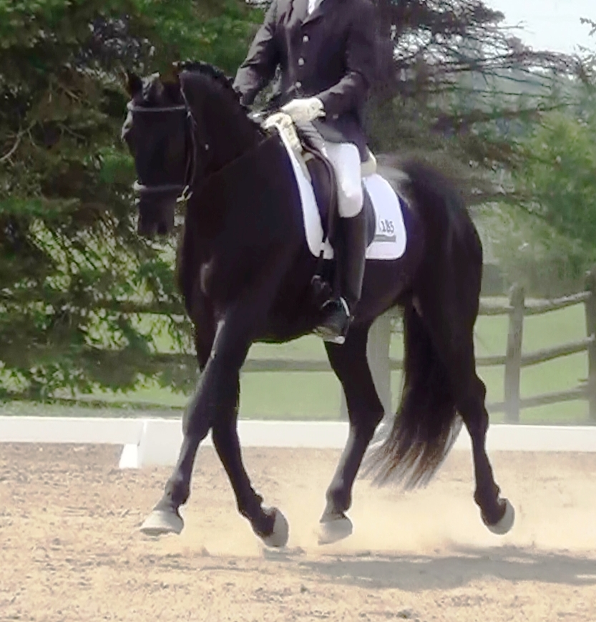***WHAT’S HAPPENING AT CENTAUR…***

***2017 SHOW DATES***

***TGIF SHOW SERIES***

A great Friday evening show series with year-end awards for the entry level rider

in both Dressage and Hunters.

**May 7**

**May 26**

**June 23**

**July 21**

**September 8**

***GOLD & SILVER DRESSAGE SHOWS***

Spring Gold Dressage – **May 14**

Summer Gold & Silver Dressage – **August 6**

***ESD / OESS Dressage & Hunter Shows***

**August 27 ** October 1 ** October 15**

Ride one test and have it count for 2 separate circuits:

1. The OADG ESD Year-end Awards (Schooling Dressage show circuit for Ottawa)
2. AND the OESS Year-End Awards

What is ESD? Equestrian Skills Developmental Shows sanctioned by the OEF

What is OADG? Ottawa Area Dressage Group

What is OESS? Ottawa East Show Series

**All Prize Lists available at www.CentaurRidingSchool.com**

***CENTAUR BREEDING FARM / HORSES FOR SALE***

**We have horses for sale from our breeding program – from babies to competing**

**… many winners & Champions on the Gold Dressage Circuit.**

***Information, Pictures & Videos: www.CentaurBreedingFarm.com***

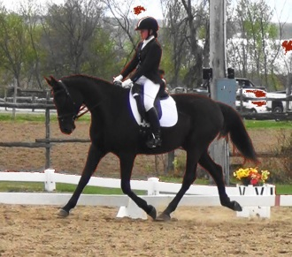

DIAMANDA CRS

*Ottawa 2015

Young Horse Champion

(also Canadian Training Level Champion)

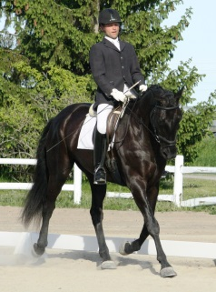

DUTCHY

*Ottawa 2014

Young Horse Champion

DELGADO

*Ottawa 2016

Young Horse Champion

